

**实 验（实训）报 告**

**项 目 名 称**  教务选课管理系统

**所属课程名称**  Web jsp开发

**项 目 类 型**  课程设计

**实验(实训)日期**  2019.6.12

**班 级**  17信息1班

**学 号**  170104100101

**姓 名**  蔡怡帅

**指导教师**  陈明晶

浙江财经大学教务处制

**目录**

摘 要 3

一、功能简介 3

二、详细代码 4

2.1登录界面 4

2.2注册界面 11

2.3学生界面 14

2.3.1个人信息 14

2.3.2成绩查看 19

2.3.3自主选课 20

2.3.4选课情况统计 24

2.4教师界面 33

2.4.1个人信息 33

2.4.2我开的课 35

2.4.3所有课程信息 37

2.4.4学生选课情况统计 40

2.5管理员界面 46

2.5.1学生信息管理 47

2.5.2学生成绩查看 49

2.5.3课程信息管理 50

2.5.4学生选课情况 55

2.5.5学生选课情况统计 56

2.5.6 教师信息查看 65

三、软件所涉及到的数据表： 65

四、Sql server中的代码（事务，视图，触发器，存储过程） 67

4.1触发器 67

4.2视图 69

五、课程设计心得 70

# 摘 要

本文描述的是基于Windows环境的选课系统，主要功能模块包括：课程信息管理与学生选课管理。使用Eclipse进行web框架的开发，使用MySql、SQL server 2008建立数据库,最终实现选课系统的各个功能。

本程序提供了管理员、教师、学生三个用户，其中管理员可以对该系统中的学生信息、课程信息进行修改、删除以及查询。学生可以查询个人信息、选课信息、成绩。教师可以增加、修改、删除、查询自己所开设的课程。

# 一、功能简介

**登录界面：**实现对角色的判断功能，用户登录无需自己选择角色；实现了保存用户名与密码功能

**注册界面：**实现根据学号/工号来区分注册角色的身份

**学生界面：**实现了选课与退选的功能；个人信息的修改；查询成绩；查看课程详细信息；对学生所选课程统计，包括选课门数，选课学分总计，按学院统计选课结果并以可交互的饼图可视化展示结果；查看选课详情

**教师界面：**个人信息的查看；对自己所开课程的查看以及所有课程的查看；自己所开课程的选课学生的查看；以可交互的饼图可视化展示所开课程各门课选课人数

**管理员界面：**实现对学生信息的删除、修改功能；课程、学生成绩的查看；教师信息的查看；课程的增加、修改、删除；以可交互的柱状图可视化展示各学院课程所选人数；多角度统计学生选课情况，包括按课程统计，按学生统计，按教师统计，按学生学分统计；显示未选课的学生名单；

# 二、详细代码

## 2.1登录界面

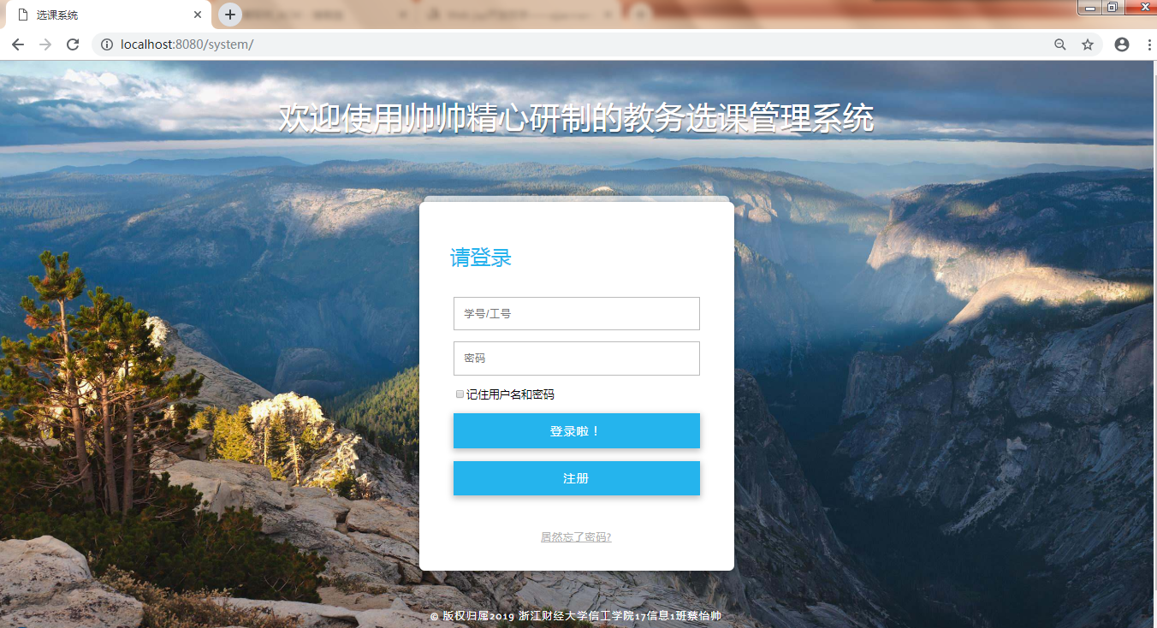

//保存用户名和密码

**protected** **void** saveUser(HttpServletRequest request, HttpServletResponse response) **throws** ServletException, IOException{

String isSave = request.getParameter("remember");

String uname = request.getParameter("username");

//System.out.println(isSave);

**if**(isSave!=**null**) {

Cookie cookie = **new** Cookie("username", URLEncoder.*encode*(uname,"UTF-8"));

cookie.setMaxAge(60*24*30);

response.addCookie(cookie);

}

}

//注销

**protected** **void** logout(HttpServletRequest request, HttpServletResponse response) **throws** ServletException, IOException{

HttpSession session = request.getSession();

session.invalidate();

RequestDispatcher rd = request.getRequestDispatcher("index.jsp");

ServletContext application = request.getServletContext();

usercount--;

application.setAttribute("usernum", usercount);

request.setAttribute("status", "注销成功！");

rd.forward(request, response);

}

//登录

**protected** **void** login(HttpServletRequest request, HttpServletResponse response) **throws** ServletException, IOException{

String uname = request.getParameter("username");//获取学号或工号

String upass = request.getParameter("userpass");//获取用户名

UserBean ub = **new** UserBean();//从数据库中获取是否存在该用户

RequestDispatcher rd;

Login user = **new** Login();

user = ub.login(uname, upass);

**if**(user.getUid()!=**null**){

System.***out***.println("登录成功！");

/* 定义application */

ServletContext application = **this**.getServletContext();

Object num = application.getAttribute("usernum");

**if**(num==**null**){

usercount = 0;

}**else**{

usercount = (Integer)num;

}

usercount++;

application.setAttribute("usernum", usercount);

/* 调用保存 cookie 的方法 */

saveUser(request, response);

/* 定义session */

HttpSession session = request.getSession();

**if**(uname.equals("蔡军帅")){

rd = request.getRequestDispatcher("loginAdmin.jsp");

session.setAttribute("username", uname);

session.setAttribute("StuName", uname);

}

**else** **if**(uname.length()==4){

rd = request.getRequestDispatcher("loginOK.jsp");

session.setAttribute("username", uname);

String StuNname = ub.getStuName(uname);

//System.out.println("StuNname "+StuNname);

session.setAttribute("StuName", StuNname);

}

**else** **if**(uname.length()==3) {

rd = request.getRequestDispatcher("loginTea.jsp");

session.setAttribute("username", uname);

String TeaNname = ub.getTeaName(uname);

session.setAttribute("TeaName", TeaNname);

}

**else**{

System.***out***.println("登录失败！");

rd = request.getRequestDispatcher("failure.jsp");

}

}**else**{

System.***out***.println("登录失败！");

rd = request.getRequestDispatcher("failure.jsp");

}

System.***out***.println("准备跳转页面");

rd.forward(request, response);

}

/**

* **@see** HttpServlet#doGet(HttpServletRequest request, HttpServletResponse response)

*/

**protected** **void** doGet(HttpServletRequest request, HttpServletResponse response) **throws** ServletException, IOException {

// **TODO** Auto-generated method stub

/*

* 不带状态的跳转：response.sendRedirext("index.jsp")

* 带状态的页面跳转：RequestDispatcher.forward(request,response)

*/

//判断登录还是登出

String act = request.getParameter("action");

**if**(act.equals("in")) {

login(request,response);

}**else** {

logout(request,response);

}

}

//登录用户类

**public** **class** Login {

**private** String uid;

**private** String ucode;

**public** String getUid() {

**return** uid;

}

**public** **void** setUid(String uid) {

**this**.uid = uid;

}

**public** String getUcode() {

**return** ucode;

}

**public** **void** setUcode(String ucode) {

**this**.ucode = ucode;

}

}

//用户类

**public** **class** UserBean {

**public** Login login(String un,String up) {

Login log = **new** Login();

String sql = "select uid,ucode from user where uid='"+un+"' and ucode='"+up+"'";

DBBean db = **new** DBBean();

db.getConnection();

ResultSet rs = db.executeQuery(sql);

**try** {

**if**(rs.next())

{

log.setUid(rs.getString(1));

log.setUcode(rs.getString(2));

}

}**catch**(Exception e) {

e.printStackTrace();

}

**return** log;

}

**public** String getStuName(String un) {

String StuName="";

String sql = "select Sname from student where Sno='"+un+"'";

System.***out***.println(sql);

DBBean db = **new** DBBean();

db.getConnection();

ResultSet rs = db.executeQuery(sql);

**try** {

**if**(rs.next())

{

StuName=rs.getString(1);

}

}**catch**(Exception e) {

e.printStackTrace();

}

**return** StuName;

}

**public** String getTeaName(String un) {

String TeaName="";

String sql = "select Tname from teacher where Tno='"+un+"'";

System.***out***.println(sql);

DBBean db = **new** DBBean();

db.getConnection();

ResultSet rs = db.executeQuery(sql);

**try** {

**if**(rs.next())

{

TeaName=rs.getString(1);

}

}**catch**(Exception e) {

e.printStackTrace();

}

**return** TeaName;

}

**public** **void** ins_stu(String un,String uc ,String um,String ug,String ud,String ugr,String date,String up) {

String sql = "insert into student ";

sql += "values('"+un+"','"+um+"','"+ug+"','"+ud+"','"+ugr+"','"+date+"','"+up+"')";

System.***out***.println(sql);

DBBean db = **new** DBBean();

db.getConnection();

db.executeUpdata(sql);

sql = "insert into user values('"+un+"','"+uc+"')";

db.getConnection();

db.executeUpdata(sql);

}

**public** **void** ins_tec(String un,String uc,String um,String ug,String ud) {

String sql = "insert into teacher ";

sql += "values('"+un+"','"+um+"','"+ug+"','"+ud+"')";

System.***out***.println(sql);

DBBean db = **new** DBBean();

db.getConnection();

db.executeUpdata(sql);

sql = "insert into user values('"+un+"','"+uc+"')";

db.getConnection();

db.executeUpdata(sql);

}

}

//数据库连接类

**public** **final** **class** DBBean {

**private** Connection conn;

**private** Statement stmt;

**private** ResultSet rs;

**public** DBBean() {

}

//建立数据库连接

**public** Connection getConnection() {

**try** {

/*使用静态数据库连接池*/

Context initContext = **new** InitialContext();

Context envContext = (Context)initContext.lookup("java:/comp/env");

DataSource ds = (DataSource)envContext.lookup("jdbc/system");

//建立连接池连接

conn = ds.getConnection();

}**catch**(Exception e) {

e.printStackTrace();

}

**return** conn;

}

// 提取SQL生成记录集

**public** ResultSet executeQuery(String sql) {

**try** {

stmt = conn.createStatement();

rs = stmt.executeQuery(sql);

System.***out***.println("返回结果集");

}**catch**(Exception e) {

e.printStackTrace();

}

**return** rs;

}

// 提取SQL添加记录

**public** **int** executeUpdata(String sql){

**int** result = 0;

**try**{

stmt = conn.createStatement();

result = stmt.executeUpdate(sql);

System.***out***.println("result "+result);

}**catch**(Exception e){

e.printStackTrace();

}

**return** result;

}

}

## 2.2注册界面

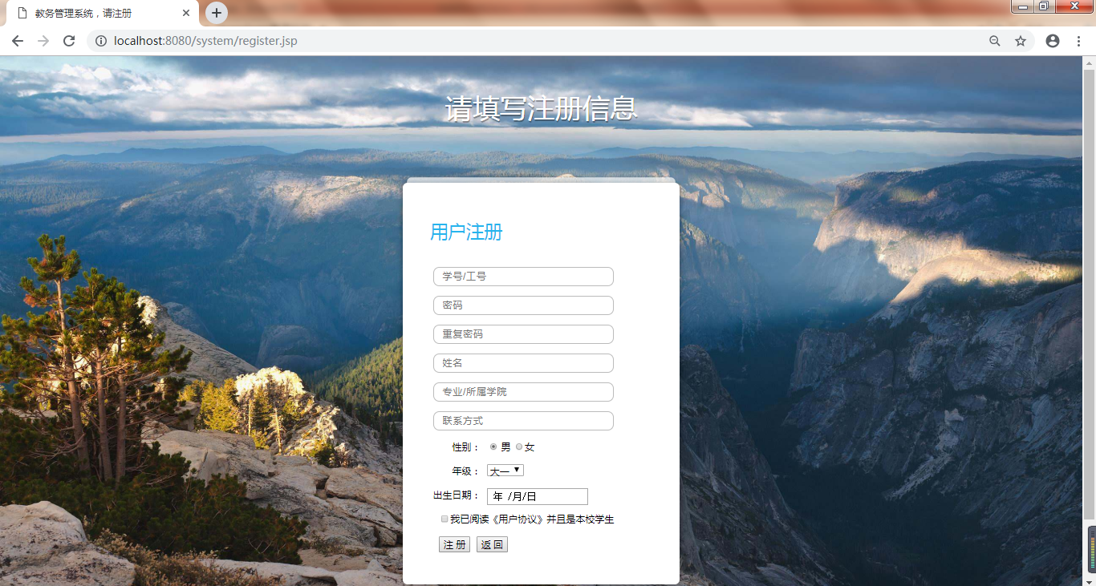

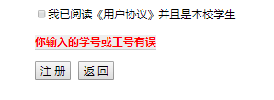

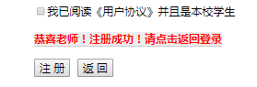

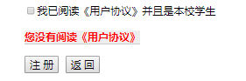

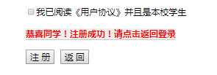

**protected** **void** doGet(HttpServletRequest request, HttpServletResponse response) **throws** ServletException, IOException {

// **TODO** Auto-generated method stub

/*

* 获取所有数据

*/

String un = request.getParameter("userNumber");

String um = request.getParameter("userName");

String uc = request.getParameter("userPass");

String cc = request.getParameter("confPass");

String ud = request.getParameter("userDept");

String up = request.getParameter("userPhone");

String ug = request.getParameter("gender");

String ub = request.getParameter("birthday");

String ugr = Integer.*toString*(Tools.*getNum*(request.getParameter("grade")));

String checkboxes[] = request.getParameterValues("read");

/*

* 处理

*/

String msg;

**if**(checkboxes==**null**)

{

msg = "您没有阅读《用户协议》";

request.setAttribute("server_info", msg);

RequestDispatcher rd = request.getRequestDispatcher("register.jsp");

rd.forward(request, response);

}

**if**(un==**null**||um==**null**||ud==**null**||up==**null**||ub.length()==0) {

msg = "请将信息填写完整";

request.setAttribute("server_info", msg);

RequestDispatcher rd = request.getRequestDispatcher("register.jsp");

rd.forward(request, response);

}

**if**(!uc.equals(cc)) {

msg = "两次输入的密码不同";

request.setAttribute("server_info", msg);

RequestDispatcher rd = request.getRequestDispatcher("register.jsp");

rd.forward(request, response);

}

//判断是un学生还是老师

//学生四位，第一位1-4

//老师一位，第一位是1

**int** f=1;

**if**(un.length()==4) {

**char** ch=un.charAt(0);

**if**(ch!='1' && ch!='2' && ch!='3'&& ch!='4') {

f=0;

}

}**else** **if**(un.length()==3) {

**char** ch=un.charAt(0);

**if**(ch!='1') {

f=0;

}**else** {

f=2;

}

}**else** {

f=0;

}

**if**(f==0) {

msg = "你输入的学号或工号有误";

request.setAttribute("server_info", msg);

RequestDispatcher rd = request.getRequestDispatcher("register.jsp");

rd.forward(request, response);

}

/*

* 1是学生，2是老师，插入数据

*/

UserBean UB = **new** UserBean();

**if**(f==1) {

UB.ins_stu(un,uc,um,ug,ud,ugr,ub,up);

msg = "恭喜同学！注册成功！请点击返回登录";

request.setAttribute("server_info", msg);

RequestDispatcher rd = request.getRequestDispatcher("register.jsp");

rd.forward(request, response);

}**else** **if**(f==2){

UB.ins_tec(un,uc,um,ug,ud);

msg = "恭喜老师！注册成功！请点击返回登录";

request.setAttribute("server_info", msg);

RequestDispatcher rd = request.getRequestDispatcher("register.jsp");

rd.forward(request, response);

}

}

## 2.3学生界面

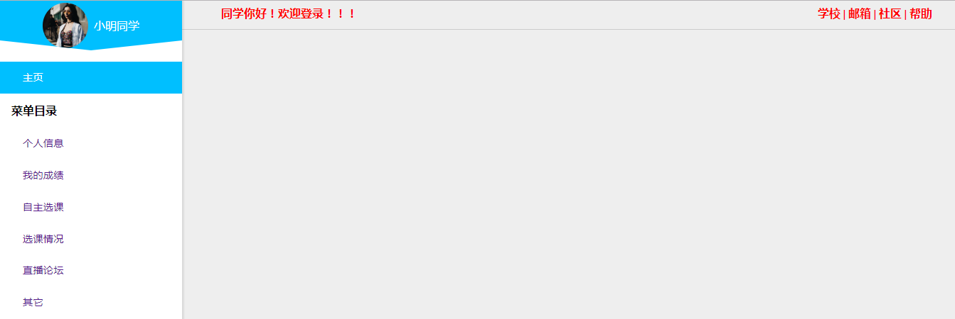

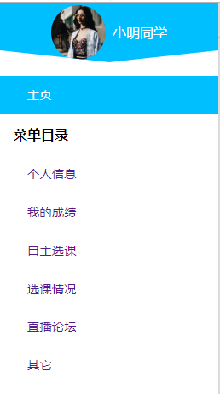

### 2.3.1个人信息

#### (1)信息查看

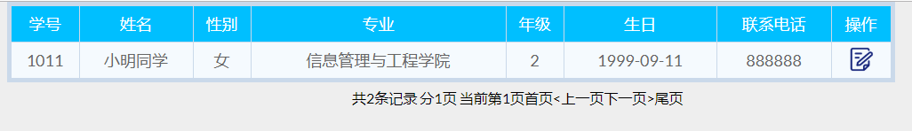

<%

String user =(String)session.getAttribute("username");

session.setAttribute("username", user);

//System.out.println("user "+user);

List studentlist = **new** ArrayList();

Student student;

Context initContext = **new** InitialContext();

Context envContext = (Context)initContext.lookup("java:/comp/env");

DataSource ds = (DataSource)envContext.lookup("jdbc/system");

Connection conn = ds.getConnection();

**int** rowCount=0;

**if**(conn != **null**){

//out.print("数据库连接成功！");

Statement stmt = conn.createStatement();

//创建结果集合，集合与表的结构类似

String sql = "select * from student where Sno=" + "'"+user+"'";

//System.out.println("sql "+sql);

ResultSet rs = stmt.executeQuery(sql);

rs.last();

rowCount=rs.getRow();

System.out.println("rowCount "+rowCount);

rs.first();

student = **new** Student(rs.getString(1),rs.getString(2),rs.getString(3),rs.getString(4),rs.getString(5),rs.getString(6),rs.getString(7),"mima");

studentlist.add(student);

**while**(rs.next()){

//System.out.println("rs"+rs);

student = **new** Student(rs.getString(1),rs.getString(2),rs.getString(3),rs.getString(4),rs.getString(5),rs.getString(6),rs.getString(7),"mima");

studentlist.add(student);

}

}

%>

#### (2)信息修改

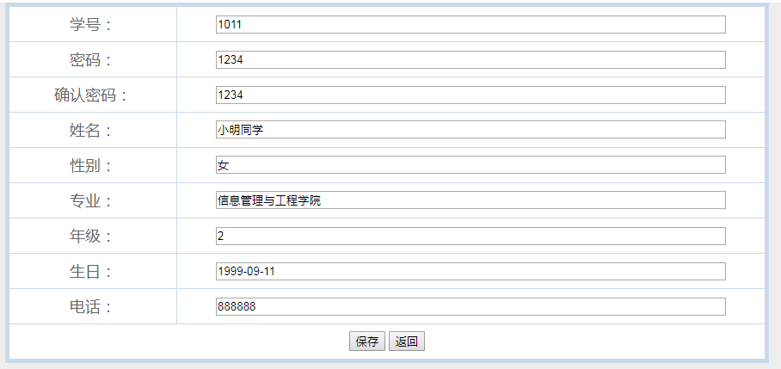

//修改学生信息

**protected** **void** modstu(HttpServletRequest request, HttpServletResponse response) **throws** ServletException, IOException {

String nid = request.getParameter("nid");

System.***out***.println("nid " +nid);

StudentBean sb = **new** StudentBean();

Student stu = sb.getStuBySno(nid);

String code = sb.getCode(nid);

stu.setScode(code);

request.setAttribute("one_student", stu);

RequestDispatcher rd;

rd = request.getRequestDispatcher("modStudent.jsp");

rd.forward(request, response);

}

//更新学生信息

**protected** **void** updstu(HttpServletRequest request, HttpServletResponse response) **throws** ServletException, IOException {

String sno = request.getParameter("sno");

String co = request.getParameter("co");

String cco = request.getParameter("cco");

String sna = request.getParameter("sna");

String sg = request.getParameter("sg");

String sd = request.getParameter("sd");

String sgr = request.getParameter("sgr");

String sb = request.getParameter("sb");

String sp = request.getParameter("sp");

StudentBean SB = **new** StudentBean();

**if**(co.equals(cco)) {

SB.upd(sno,sna,sg,sd,sgr,sb,sp,co);

}

**else** {

response.getWriter().print("<script>alert('对不起，你两次输入的密码不一致！')</script>");

}

String admin = request.getParameter("admin");

System.***out***.println("admin "+admin+"!");

**if**(admin.equals("1")) {

response.sendRedirect("studentInformation.jsp");

}

**else**{

response.sendRedirect("myInformation.jsp");

}

}

/**

* **@see** HttpServlet#doGet(HttpServletRequest request, HttpServletResponse response)

*/

**protected** **void** doGet(HttpServletRequest request, HttpServletResponse response) **throws** ServletException, IOException {

// **TODO** Auto-generated method stub

String act = request.getParameter("action");

**if**(act.equals("add")) {

addstu(request, response);

}**else** **if**(act.equals("mod")) {

modstu(request, response);

}**else** **if**(act.equals("del")) {

delstu(request, response);

}**else** **if**(act.equals("upd")) {

updstu(request, response);

}**else** **if**(act.equals("save")) {

insstu(request, response);

}

}

//学生信息与数据库连接类

**public** **class** StudentBean {

**public** Student getStuBySno(String nid) {

Student stu = **new** Student();

String sql = "select * from student where Sno="+nid;

DBBean db = **new** DBBean();

db.getConnection();

ResultSet rs = db.executeQuery(sql);

**try** {

**if**(rs.next()) {

stu.setSno(rs.getString(1));

stu.setSname(rs.getString(2));

stu.setSgender(rs.getString(3));

stu.setSdept(rs.getString(4));

stu.setSgrade(rs.getString(5));

stu.setSbirth(rs.getString(6));

stu.setSphone(rs.getString(7));

}

}**catch**(Exception e) {

e.printStackTrace();

}

**return** stu;

}

**public** **void** del(String nid) {

String sql = "delete from student where Sno="+nid;

DBBean db = **new** DBBean();

db.getConnection();

db.executeUpdata(sql);

}

**public** String getCode(String nid) {

String sql = "select ucode from user where uid="+nid;

String code="";

DBBean db = **new** DBBean();

db.getConnection();

ResultSet rs = db.executeQuery(sql);

**try** {

**if**(rs.next()) {

code = rs.getString(1);

}

}**catch**(Exception e) {

e.printStackTrace();

}

**return** code;

}

**public** **void** upd(String sno,String sna,String sg,String sd,String sgr,String sb,String sp,String co) {

String sql = "update student set Sno='"+sno+"',Sname='"+sna+"',Sgender='"+sg;

sql += "',Sdept='"+sd+"',Sgrade='"+sgr+"',Sbirth='"+sb+"',Sphone='"+sp+"' where Sno="+"'"+sno+"'";

System.***out***.println("here: "+sql);

DBBean db = **new** DBBean();

db.getConnection();

db.executeUpdata(sql);

sql="update user set uid='"+sno+"',ucode='"+co+"' where uid="+"'"+sno+"'";

System.***out***.println("here: "+sql);

db.getConnection();

db.executeUpdata(sql);

}

}

### 2.3.2成绩查看

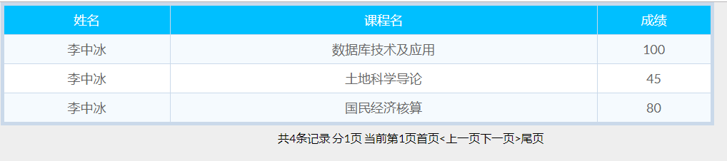

<%

String user =(String)session.getAttribute("username");

session.setAttribute("username", user);

//数据库连接实例

String driverName = "com.mysql.jdbc.Driver";

Class.forName(driverName).newInstance();

//Class c = new Class(driverName);

String url="jdbc:mysql://localhost:3306/courseselectsystem?user=root&password=caiyishuai";

url += "&useUnicode=true&characterEncoding=utf8";

//建立数据库连接

Connection conn = DriverManager.getConnection(url);

//out.println(conn);//能输出就连接成功了

//建立语句执行环境

Statement stat = conn.createStatement();

//执行sql语句

String sql = "select Sname,Cname,Score from v_grade where Sno="+"'"+user+"'";

System.out.println("sql "+sql);

//弄个对象来接它，结果集

ResultSet rs = stat.executeQuery(sql);

%>

### 2.3.3自主选课

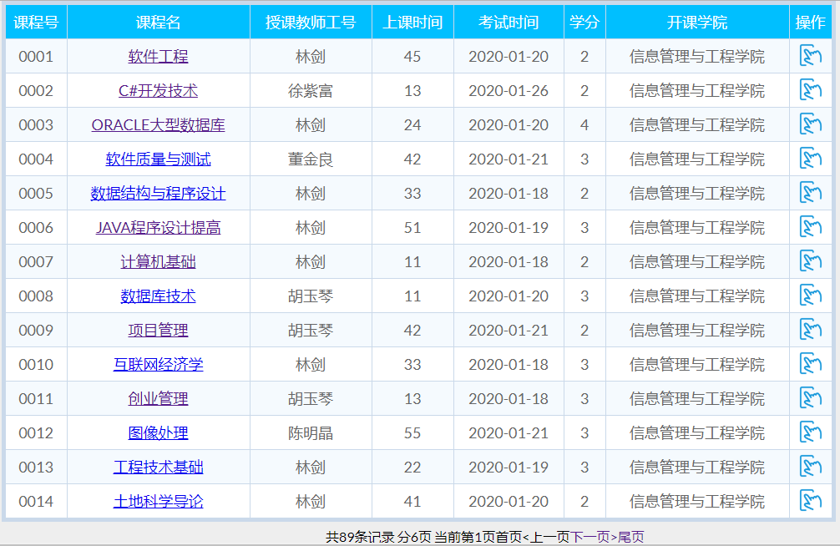

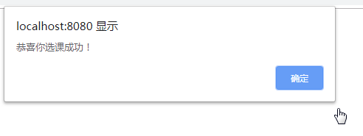

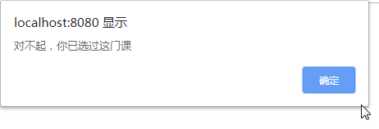

<%

String user =(String)session.getAttribute("username");

session.setAttribute("username", user);

List coursetlist = **new** ArrayList();

Course course;

Context initContext = **new** InitialContext();

Context envContext = (Context)initContext.lookup("java:/comp/env");

DataSource ds = (DataSource)envContext.lookup("jdbc/system");

Connection conn = ds.getConnection();

**int** rowCount=0;

**if**(conn != **null**){

Statement stmt = conn.createStatement();

ResultSet rs = stmt.executeQuery("select * from v_choose_course");

rs.last();

rowCount=rs.getRow();

rs.first();

course = **new** Course(rs.getString(1),rs.getString(2),rs.getString(3),rs.getString(4),rs.getString(5),rs.getString(6),rs.getString(7));

coursetlist.add(course);

**while**(rs.next()){

course = **new** Course(rs.getString(1),rs.getString(2),rs.getString(3),rs.getString(4),rs.getString(5),rs.getString(6),rs.getString(7));

coursetlist.add(course);

}

rs.last();

rowCount=rs.getRow();

rs.close();

stmt.close();

conn.close();

}

%>

<%

**if**((request.getAttribute("is_success"))!=**null**)

{

String ok =(String)request.getAttribute("is_success");

**if**(ok.equals("1")){

%>

<script>

alert('恭喜你选课成功！');

</script>

<%

}**else**{

%>

<script>

alert('对不起，你已选过这门课');

</script>

<%

}

}

**int** who=0;

**if**(user.equals("蔡军帅")){

who=1;

}**else** **if**(user.length()==3){

who=2;

}

%>

//学生选课

**protected** **void** doGet(HttpServletRequest request, HttpServletResponse response) **throws** ServletException, IOException {

// **TODO** Auto-generated method stub

String act = request.getParameter("action");

**if**(act.equals("ins")) {

choose(request, response);

}**else** **if**(act.equals("del")) {

delete(request, response);

}**else** **if**(act.equals("find")) {

find(request,response);

}

}

**protected** **void** choose(HttpServletRequest request, HttpServletResponse response) **throws** ServletException, IOException {

String Cno = request.getParameter("Cno");

String Sno = request.getParameter("Sno");

SelectedBean Sb = **new** SelectedBean();

String ok = Sb.add(Sno,Cno);

RequestDispatcher rd = request.getRequestDispatcher("chooseCourse.jsp");

request.setAttribute("is_success", ok);

rd.forward(request, response);

}

//选课与数据库连接类

**public** **class** SelectedBean {

**public** String add(String Sno, String Cno) {

String ok="1";

String sql = "insert into selection(Sno,Cno) values("+"'"+Sno+"','"+Cno+"')";

System.***out***.println("here: "+sql);

DBBean db = **new** DBBean();

db.getConnection();

//以前没选过

**if**(search(Sno,Cno)==1) {

//那么选

db.executeUpdata(sql);

}**else** {

ok="0";

}

//ok=1表示选课成功

**return** ok;

}

**public** **int** search(String Sno,String Cno) {

**int** ok=1;

String sql = "select * from selection where Sno="+"'"+Sno+"' and Cno='"+Cno+"'";

System.***out***.println("here2: "+sql);

DBBean db = **new** DBBean();

db.getConnection();

ResultSet rs = db.executeQuery(sql);

System.***out***.println("rs "+rs);

**try** {

**if** (rs.next()) {

//已经存在的了，就不ok

ok=0;

}

}**catch**(Exception e){

e.printStackTrace();

}

System.***out***.println("ok "+ok);

**return** ok;

}

**public** **void** del(String Sno,String Cno) {

String sql = "delete from selection where Sno="+"'"+Sno+"' and Cno='"+Cno+"'";

System.***out***.println("here2: "+sql);

DBBean db = **new** DBBean();

db.getConnection();

db.executeUpdata(sql);

}

}

### 2.3.4选课情况统计

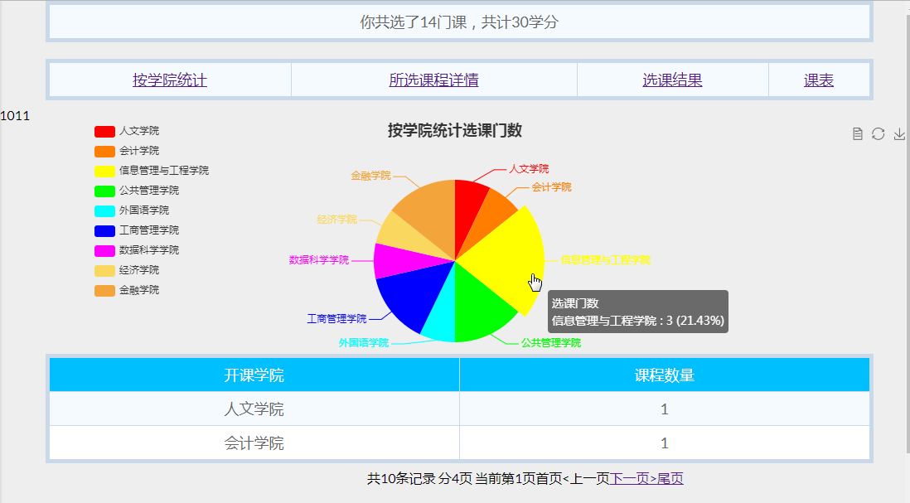

#### 选课门数及学分



<%

String user =(String)session.getAttribute("username");

session.setAttribute("username", user);

Context initContext = **new** InitialContext();

Context envContext = (Context)initContext.lookup("java:/comp/env");

DataSource ds = (DataSource)envContext.lookup("jdbc/system");

Connection conn = ds.getConnection();

Statement stmt = conn.createStatement();

//执行sql语句

String sql = "select SUM(course.Credit) ";

sql+="from v_selected_stu_tea_cou,course ";

sql+="where v_selected_stu_tea_cou.Cno = course.Cno ";

sql+="and Sno='"+user+"'";

System.out.println("sql "+sql);

ResultSet rs = stmt.executeQuery(sql);

**int** fen=0;

**while**(rs.next()){

fen=rs.getInt(1);

}

initContext = **new** InitialContext();

envContext = (Context)initContext.lookup("java:/comp/env");

ds = (DataSource)envContext.lookup("jdbc/system");

conn = ds.getConnection();

//out.print("数据库连接成功！");

stmt = conn.createStatement();

**int** men=0;

sql = "select count(*) ";

sql+="from v_selected_stu_tea_cou ";

sql+="where Sno='"+user+"'";

System.out.println("sql "+sql);

//弄个对象来接它，结果集

ResultSet rs2 = stmt.executeQuery(sql);

**while**(rs2.next()){

men=rs2.getInt(1);

}

%>

#### 按学院统计

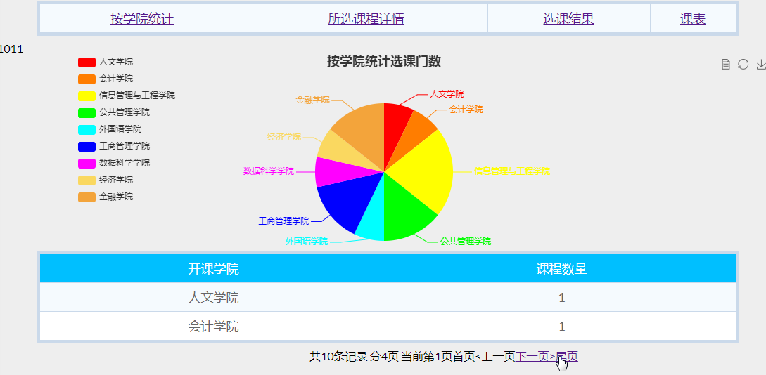

**protected** **void** doPost(HttpServletRequest request, HttpServletResponse response)

**throws** ServletException, IOException {

System.***out***.println("hhh");

String user = (String)request.getParameter("user");

System.***out***.println("useruser "+user);

String sql="Select College,Count(*) from course where cno in ";

sql+="(SELECT Cno from v_choose_course where Cno in ";

sql+="(SELECT Cno from v_selected_admin where Sno='"+user+"')) group by College";

List<Product> list = **new** ArrayList<Product>();

DBBean db = **new** DBBean();

db.getConnection();

ResultSet rs = db.executeQuery(sql);

**try** {

**while**(rs.next())

{

list.add(**new** Product(rs.getString(1), rs.getInt(2)));

System.***out***.println(rs.getString(1));

}

}**catch**(Exception e) {

e.printStackTrace();

}

//System.out.println("这里是doPost");

Gson gson2 = **new** Gson();

String json = gson2.toJson(list);

System.***out***.println(json);

// 将json字符串数据返回给前端

response.setContentType("text/html; charset=utf-8");

response.getWriter().write(json);

}

<script type=*"text/javascript"*>

**var** myChart = echarts.init(document.getElementById('main'));

**var** user = document.getElementById('xuehao').innerHTML;

//alert(user);

//3.初始化，默认显示标题，图例和xy空坐标轴

myChart.setOption({

title : {

text: '按学院统计选课门数',

//subtext: '纯属虚构',

x:'center'

},

tooltip : {

trigger: 'item',

formatter: "{a} <br/>{b} : {c} ({d}%)"

},

legend: {

orient : 'vertical',

x : 'left',

data:[]

},

toolbox: {

show : **true**,

feature : {

mark : {show: **true**},

dataView : {show: **true**, readOnly: **false**},

magicType : {

show: **true**,

type: ['pie', 'funnel'],

option: {

funnel: {

x: '25%',

width: '50%',

funnelAlign: 'left',

max: 1548

}

}

},

restore : {show: **true**},

saveAsImage : {show: **true**}

}

},

calculable : **true**,

series : [

{

name:'选课门数',

type:'pie',

radius : '65%',

center: ['50%', '60%'],

data:[]

}

]

});

//4.设置加载动画(非必须)

myChart.showLoading(); //数据加载完之前先显示一段简单的loading动画

//5.定义数据存放数组(动态变)

**var** statisticsData = []; //这是我自己建的空数组，为了把异步拿到的数据push进去

**var** statisticsName = [];

//6.ajax发起数据请求

$.ajax({

type : "post",

async : **true**, //异步请求（同步请求将会锁住浏览器，其他操作须等请求完成才可执行）

url : "stuCouEcharts", //请求发送到TestServlet

data : {'user':user},

dataType : "json", //返回数据形式为json

//7.请求成功后接收数据name+num两组数据

success : **function**(result) {

//result为服务器返回的json对象

**if** (result) {

//8.取出数据存入数组

**for** (**var** i = 0; i < result.length; i++) {

**var** statisticsObj = {name:'',value:''}; //因为ECharts里边需要的的数据格式是这样的

statisticsObj.name = result[i].name;

statisticsName.push(result[i].name);

statisticsObj.value = result[i].num;

statisticsData.push(statisticsObj); //把拿到的异步数据push进我自己建的数组里

}

myChart.hideLoading(); //隐藏加载动画

//9.覆盖操作-根据数据加载数据图表

myChart.setOption({

legend: {

show: **true**,

x: '10%',

data: statisticsName //这里是图表上的数据

},

series: [{

name: '选课门数',

type: 'pie',

radius : '70%',

center: ['50%', '60%'],

data: statisticsData, //这里是异步加载系列列表

itemStyle: {

normal: {

color: **function**(params) {

// build a color map as your need.

**var** colorList = [

'#FF0000','#FF7D00','#FFFF00','#00FF00','#00FFFF',

'#0000FF','#FF00FF','#FAD860','#F3A43B','#60C0DD',

'#D7504B','#C6E579','#F4E001','#F0805A','#26C0C0'

];

**return** colorList[params.dataIndex];

},

}

},

}]

});

}

},

error : **function**(errorMsg) {

//请求失败时执行该函数

alert("图表请求数据失败!");

myChart.hideLoading();

}

})

</script>

**protected** **void** doPost(HttpServletRequest request, HttpServletResponse response)

**throws** ServletException, IOException {

System.***out***.println("hhh");

String user = (String)request.getParameter("user");

System.***out***.println("useruser "+user);

String sql="Select College,Count(*) from course where cno in ";

sql+="(SELECT Cno from v_choose_course where Cno in ";

sql+="(SELECT Cno from v_selected_admin where Sno='"+user+"')) group by College";

List<Product> list = **new** ArrayList<Product>();

DBBean db = **new** DBBean();

db.getConnection();

ResultSet rs = db.executeQuery(sql);

**try** {

**while**(rs.next())

{

list.add(**new** Product(rs.getString(1), rs.getInt(2)));

System.***out***.println(rs.getString(1));

}

}**catch**(Exception e) {

e.printStackTrace();

}

//System.out.println("这里是doPost");

Gson gson2 = **new** Gson();

String json = gson2.toJson(list);

System.***out***.println(json);

// 将json字符串数据返回给前端

response.setContentType("text/html; charset=utf-8");

response.getWriter().write(json);

}

#### 所选课程详情

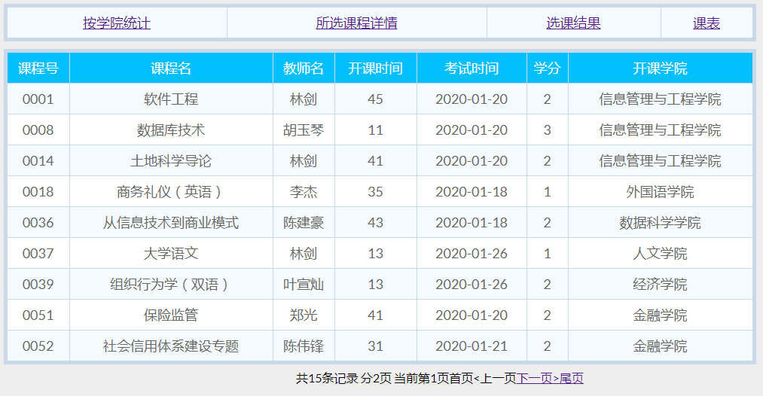

<%

String user =(String)session.getAttribute("username");

session.setAttribute("username", user);

List coursetlist = **new** ArrayList();

Course course;

Context initContext = **new** InitialContext();

Context envContext = (Context)initContext.lookup("java:/comp/env");

DataSource ds = (DataSource)envContext.lookup("jdbc/system");

Connection conn = ds.getConnection();

//out.print("数据库连接成功！");

Statement stmt = conn.createStatement();

//创建结果集合，集合与表的结构类似

String sql="SELECT * from v_choose_course where Cno in (SELECT Cno from v_selected_admin where Sno="+"'"+user+"'"+")";

ResultSet rs = stmt.executeQuery(sql);

%>

#### 选课结果

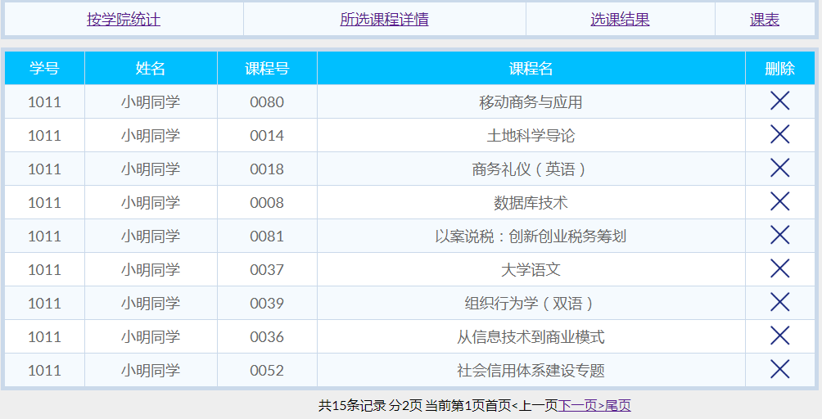

<%

String user =(String)session.getAttribute("username");

session.setAttribute("username", user);

List coursetlist = **new** ArrayList();

Course course;

Context initContext = **new** InitialContext();

Context envContext = (Context)initContext.lookup("java:/comp/env");

DataSource ds = (DataSource)envContext.lookup("jdbc/system");

Connection conn = ds.getConnection();

//out.print("数据库连接成功！");

Statement stmt = conn.createStatement();

//创建结果集合，集合与表的结构类似

ResultSet rs = stmt.executeQuery("select * from v_selected_admin where Sno="+"'"+user+"'");

%>

//退选课程

**protected** **void** delete(HttpServletRequest request, HttpServletResponse response) **throws** ServletException, IOException {

String Cno = request.getParameter("Cno");

String Sno = request.getParameter("Sno");

SelectedBean Sb = **new** SelectedBean();

Sb.del(Sno,Cno);

response.sendRedirect("mySelected.jsp");

}

## 2.4教师界面

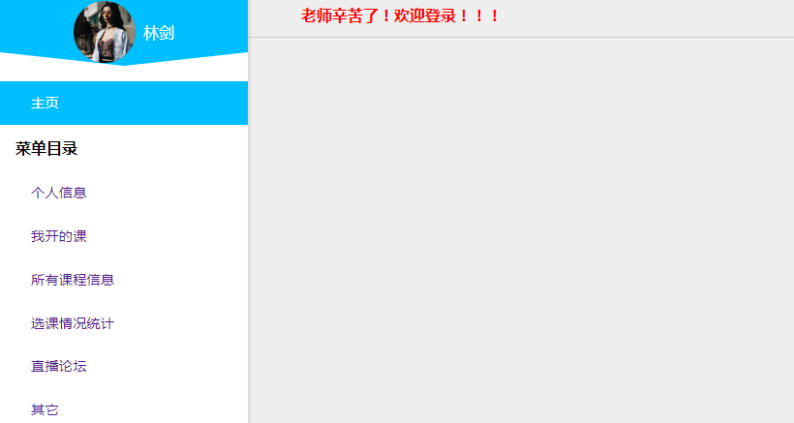

### 2.4.1个人信息

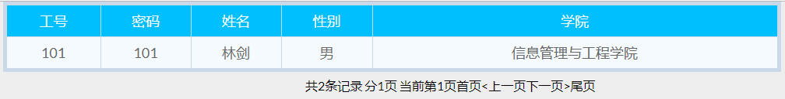

<%

String user =(String)session.getAttribute("username");

session.setAttribute("username", user);

//System.out.println("user "+user);

List TeacherList = **new** ArrayList();

Teacher teacher;

Context initContext = **new** InitialContext();

Context envContext = (Context)initContext.lookup("java:/comp/env");

DataSource ds = (DataSource)envContext.lookup("jdbc/system");

Connection conn = ds.getConnection();

**int** rowCount=0;

**if**(conn != **null**){

Statement stmt = conn.createStatement();

//创建结果集合，集合与表的结构类似

String sql = "select * from teacher where Tno=" + "'"+user+"'";

ResultSet rs = stmt.executeQuery(sql);

rs.last();

rowCount=rs.getRow();

System.out.println("rowCount "+rowCount);

rs.first();

teacher = **new** Teacher(rs.getString(1),rs.getString(2),rs.getString(3),rs.getString(4),"mima");

TeacherList.add(teacher);

**while**(rs.next()){

//System.out.println("rs"+rs);

teacher = **new** Teacher(rs.getString(1),rs.getString(2),rs.getString(3),rs.getString(4),"mima");

TeacherList.add(teacher);

}

}

%>

//教师类

**public** **class** Teacher {

**private** String Tno;

**private** String Tname;

**private** String Tg;

**private** String Tc;

**private** String Tcode;

**public** String getTno() {

**return** Tno;

}

**public** **void** setTno(String tno) {

Tno = tno;

}

**public** String getTname() {

**return** Tname;

}

**public** **void** setTname(String tname) {

Tname = tname;

}

**public** String getTg() {

**return** Tg;

}

**public** **void** setTg(String tg) {

Tg = tg;

}

**public** String getTc() {

**return** Tc;

}

**public** **void** setTc(String tc) {

Tc = tc;

}

**public** String getTcode() {

**return** Tcode;

}

**public** **void** setScode(String scode) {

Tcode = scode;

}

**public** Teacher(String a, String b, String c, String d,String e) {

**super**();

**this**.Tno = a;

**this**.Tname = b;

**this**.Tg = c;

**this**.Tc = d;

**this**.Tcode = e;

}

**public** Teacher() {

}

}

### 2.4.2我开的课

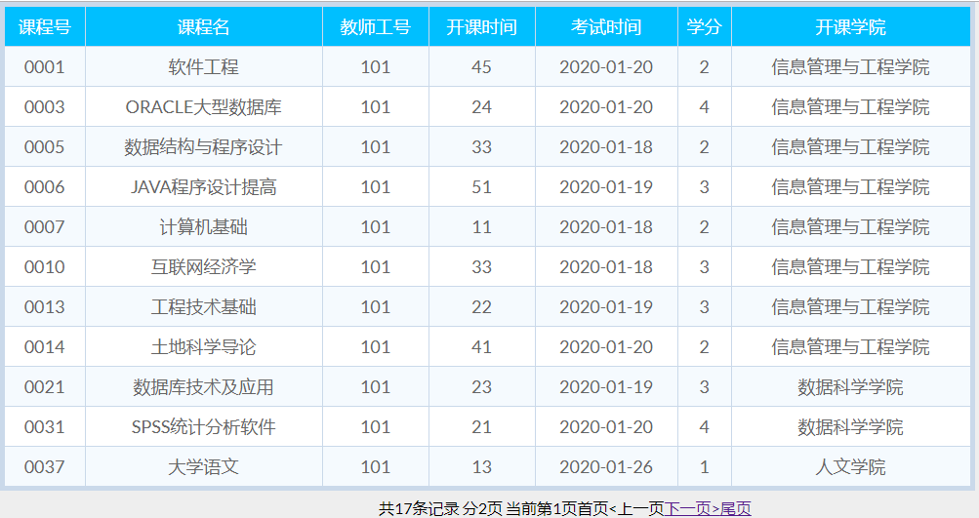

<%

String user =(String)session.getAttribute("username");

session.setAttribute("username", user);

//数据库连接实例

String driverName = "com.mysql.jdbc.Driver";

Class.forName(driverName).newInstance();

//Class c = new Class(driverName);

String url="jdbc:mysql://localhost:3306/courseselectsystem?user=root&password=caiyishuai";

url += "&useUnicode=true&characterEncoding=utf8";

//建立数据库连接

Connection conn = DriverManager.getConnection(url);

//out.println(conn);//能输出就连接成功了

//建立语句执行环境

Statement stat = conn.createStatement();

//执行sql语句

String sql = "select * from course where Tno="+"'"+user+"'";

System.out.println("sql "+sql);

ResultSet rs = stat.executeQuery(sql);

List coursetlist = **new** ArrayList();

Course course;

rs.last();

**int** rowCount=0;

rowCount=rs.getRow();

rs.first();

course = **new** Course(rs.getString(1),rs.getString(2),rs.getString(3),rs.getString(4),rs.getString(5),rs.getString(6),rs.getString(7));

coursetlist.add(course);

**while**(rs.next()){

course = **new** Course(rs.getString(1),rs.getString(2),rs.getString(3),rs.getString(4),rs.getString(5),rs.getString(6),rs.getString(7));

coursetlist.add(course);

}

rs.last();

rowCount=rs.getRow();

rs.close();

stat.close();

conn.close();

%>

### 2.4.3所有课程信息

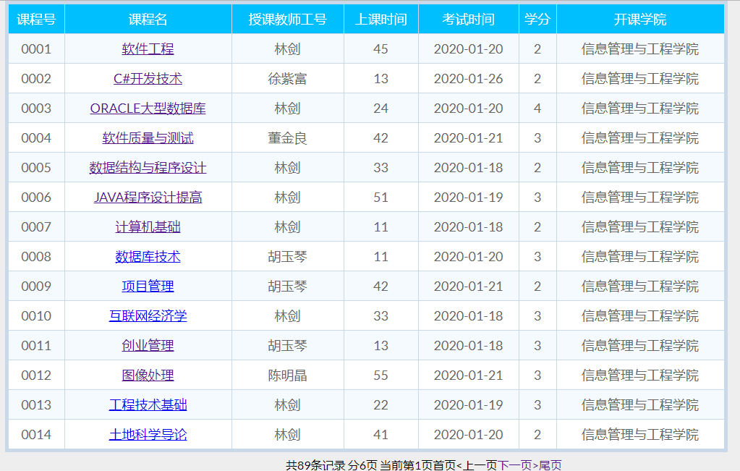

<%

String user =(String)session.getAttribute("username");

session.setAttribute("username", user);

List coursetlist = **new** ArrayList();

Course course;

Context initContext = **new** InitialContext();

Context envContext = (Context)initContext.lookup("java:/comp/env");

DataSource ds = (DataSource)envContext.lookup("jdbc/system");

Connection conn = ds.getConnection();

**int** rowCount=0;

**if**(conn != **null**){

Statement stmt = conn.createStatement();

ResultSet rs = stmt.executeQuery("select * from v_choose_course");

rs.last();

rowCount=rs.getRow();

rs.first();

course = **new** Course(rs.getString(1),rs.getString(2),rs.getString(3),rs.getString(4),rs.getString(5),rs.getString(6),rs.getString(7));

coursetlist.add(course);

**while**(rs.next()){

course = **new** Course(rs.getString(1),rs.getString(2),rs.getString(3),rs.getString(4),rs.getString(5),rs.getString(6),rs.getString(7));

coursetlist.add(course);

}

rs.last();

rowCount=rs.getRow();

rs.close();

stmt.close();

conn.close();

}

**int** who=0;

**if**(user.equals("蔡军帅")){

who=1;

}**else** **if**(user.length()==3){

who=2;

}

%>

//课程类

**public** **class** Course {

**private** String Cno;

**private** String Cname;

**private** String Tno;

**private** String Time;

**private** String TestTime;

**private** String Credit;

**private** String College;

**public** String getCno() {

**return** Cno;

}

**public** **void** setCno(String cno) {

Cno = cno;

}

**public** String getCname() {

**return** Cname;

}

**public** **void** setCname(String cname) {

Cname = cname;

}

**public** String getTno() {

**return** Tno;

}

**public** **void** setTno(String tno) {

Tno = tno;

}

**public** String getTime() {

**return** Time;

}

**public** **void** setTime(String time) {

Time = time;

}

**public** String getTestTime() {

**return** TestTime;

}

**public** **void** setTestTime(String testTime) {

TestTime = testTime;

}

**public** String getCredit() {

**return** Credit;

}

**public** **void** setCredit(String credit) {

Credit = credit;

}

**public** String getCollege() {

**return** College;

}

**public** **void** setCollege(String college) {

College = college;

}

**public** Course(String Cno, String Cname, String Tno, String Time,String TestTime, String Credit, String College) {

**super**();

**this**.Cno = Cno;

**this**.Cname = Cname;

**this**.Tno = Tno;

**this**.Time = Time;

**this**.TestTime = TestTime;

**this**.Credit = Credit;

**this**.College = College;

}

**public** Course() {

}

}

### 2.4.4学生选课情况统计

#### (1)所开课程统计学生人数

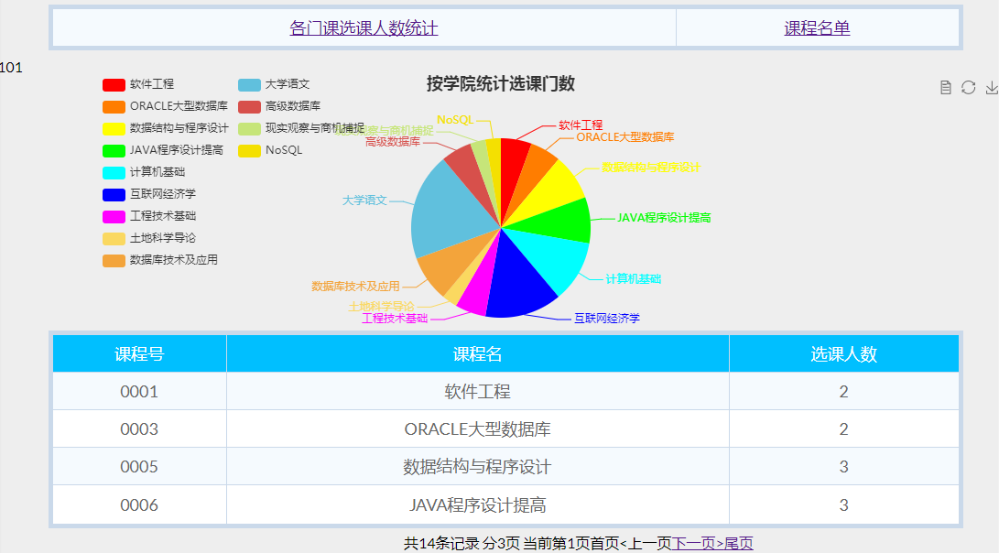

<%

String user =(String)session.getAttribute("username");

session.setAttribute("username", user);

//数据库连接实例

String driverName = "com.mysql.jdbc.Driver";

Class.forName(driverName).newInstance();

//Class c = new Class(driverName);

String url="jdbc:mysql://localhost:3306/courseselectsystem?user=root&password=caiyishuai";

url += "&useUnicode=true&characterEncoding=utf8";

Connection conn = DriverManager.getConnection(url);

Statement stat = conn.createStatement();

String sql = "select Cno,Cname,COUNT(*) from v_selected_stu_tea_cou where Tno='"+user+"' group by Cno";

System.out.println("界面sql "+sql);

ResultSet rs = stat.executeQuery(sql);

%>

<script type=*"text/javascript"*>

**var** myChart = echarts.init(document.getElementById('main'));

**var** user = document.getElementById('xuehao').innerHTML;

//alert(user);

//3.初始化，默认显示标题，图例和xy空坐标轴

myChart.setOption({

title : {

text: '按学院统计选课门数',

//subtext: '纯属虚构',

x:'center'

},

tooltip : {

trigger: 'item',

formatter: "{a} <br/>{b} : {c} ({d}%)"

},

legend: {

orient : 'vertical',

x : 'left',

data:[]

},

toolbox: {

show : **true**,

feature : {

mark : {show: **true**},

dataView : {show: **true**, readOnly: **false**},

magicType : {

show: **true**,

type: ['pie', 'funnel'],

option: {

funnel: {

x: '25%',

width: '50%',

funnelAlign: 'left',

max: 1548

}

}

},

restore : {show: **true**},

saveAsImage : {show: **true**}

}

},

calculable : **true**,

series : [

{

name:'选课门数',

type:'pie',

radius : '65%',

center: ['50%', '60%'],

data:[]

}

]

});

//4.设置加载动画(非必须)

myChart.showLoading(); //数据加载完之前先显示一段简单的loading动画

//5.定义数据存放数组(动态变)

**var** statisticsData = []; //这是我自己建的空数组，为了把异步拿到的数据push进去

**var** statisticsName = [];

//6.ajax发起数据请求

$.ajax({

type : "post",

async : **true**, //异步请求（同步请求将会锁住浏览器，其他操作须等请求完成才可执行）

url : "teaCouEcharts", //请求发送到TestServlet

data : {'user':user},

dataType : "json", //返回数据形式为json

//7.请求成功后接收数据name+num两组数据

success : **function**(result) {

//result为服务器返回的json对象

**if** (result) {

//8.取出数据存入数组

**for** (**var** i = 0; i < result.length; i++) {

**var** statisticsObj = {name:'',value:''}; //因为ECharts里边需要的的数据格式是这样的

statisticsObj.name = result[i].name;

statisticsName.push(result[i].name);

statisticsObj.value = result[i].num;

statisticsData.push(statisticsObj); //把拿到的异步数据push进我自己建的数组里

}

myChart.hideLoading(); //隐藏加载动画

//9.覆盖操作-根据数据加载数据图表

myChart.setOption({

legend: {

show: **true**,

x: '10%',

data: statisticsName //这里是图表上的数据

},

series: [{

name: '选课门数',

type: 'pie',

radius : '70%',

center: ['50%', '60%'],

data: statisticsData, //这里是异步加载系列列表

itemStyle: {

normal: {

color: **function**(params) {

// build a color map as your need.

**var** colorList = [

'#FF0000','#FF7D00','#FFFF00','#00FF00','#00FFFF',

'#0000FF','#FF00FF','#FAD860','#F3A43B','#60C0DD',

'#D7504B','#C6E579','#F4E001','#F0805A','#26C0C0'

];

**return** colorList[params.dataIndex];

},

}

},

}]

});

}

},

error : **function**(errorMsg) {

//请求失败时执行该函数

alert("图表请求数据失败!");

myChart.hideLoading();

}

})

</script>

**protected** **void** doPost(HttpServletRequest request, HttpServletResponse response) **throws** ServletException, IOException {

// **TODO** Auto-generated method stub

System.***out***.println("hhh");

String user = (String)request.getParameter("user");

System.***out***.println("useruser "+user);

String sql="select Cname,COUNT(*) from v_selected_stu_tea_cou where Tno='"+user+"' group by Cno";

List<Product> list = **new** ArrayList<Product>();

DBBean db = **new** DBBean();

db.getConnection();

ResultSet rs = db.executeQuery(sql);

**try** {

System.***out***.println("这里是teachCouE");

**while**(rs.next())

{

list.add(**new** Product(rs.getString(1), rs.getInt(2)));

System.***out***.println(rs.getString(1));

}

}**catch**(Exception e) {

e.printStackTrace();

}

Gson gson2 = **new** Gson();

String json = gson2.toJson(list);

System.***out***.println(json);

// 将json字符串数据返回给前端

response.setContentType("text/html; charset=utf-8");

response.getWriter().write(json);

}

#### (2)所开课程的课程名单

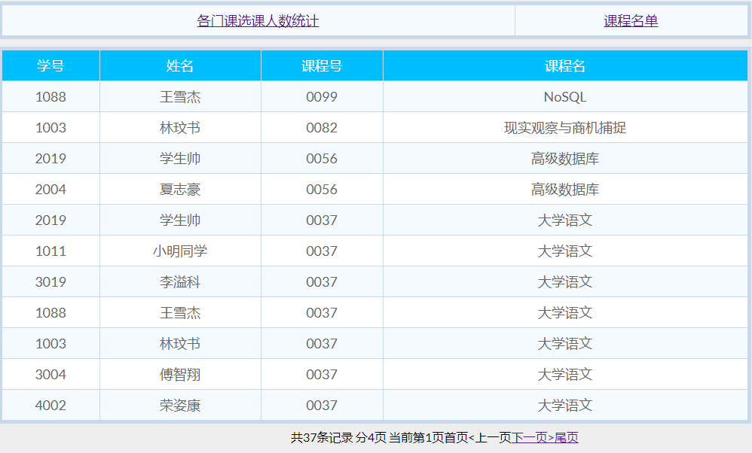

<%

String user =(String)session.getAttribute("username");

session.setAttribute("username", user);

//数据库连接实例

String driverName = "com.mysql.jdbc.Driver";

Class.forName(driverName).newInstance();

String url="jdbc:mysql://localhost:3306/courseselectsystem?user=root&password=caiyishuai";

url += "&useUnicode=true&characterEncoding=utf8";

Connection conn = DriverManager.getConnection(url);

Statement stat = conn.createStatement();

String sql = "select Sno,Sname,Cno,Cname from v_selected_stu_tea_cou where Tno='"+user+"' order by Cno desc";

System.out.println("sql "+sql);

ResultSet rs = stat.executeQuery(sql);

%>

## 2.5管理员界面

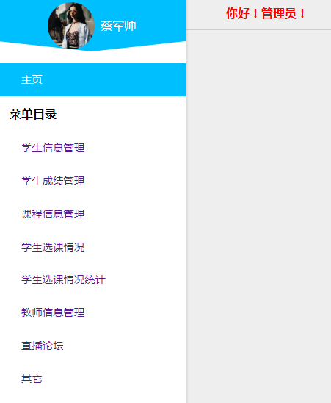

### 2.5.1学生信息管理

#### (1)信息查看

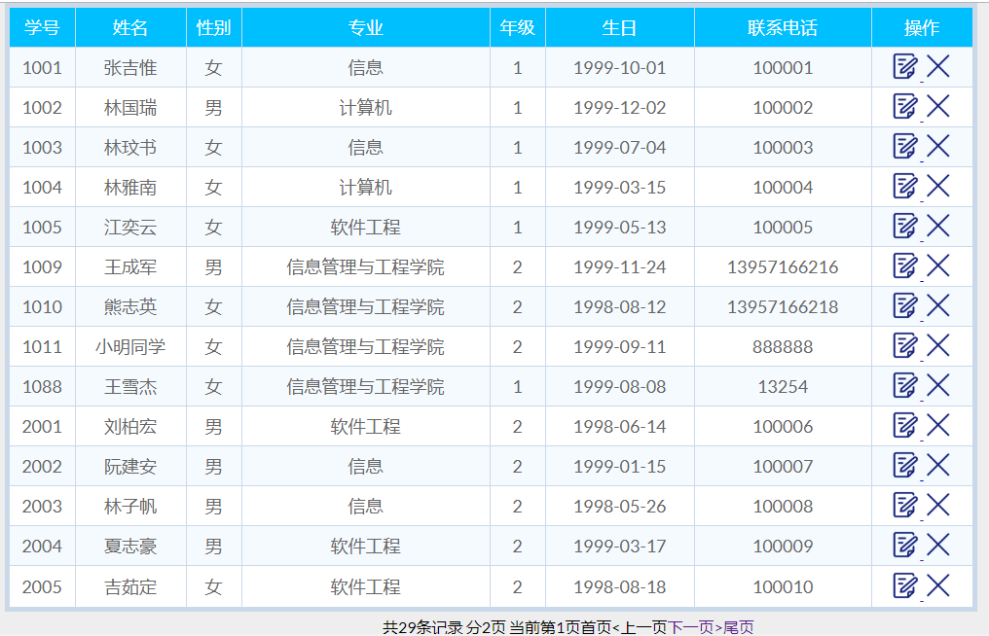

<%

List studentlist = **new** ArrayList();

Student student;

Context initContext = **new** InitialContext();

Context envContext = (Context)initContext.lookup("java:/comp/env");

DataSource ds = (DataSource)envContext.lookup("jdbc/system");

Connection conn = ds.getConnection();

**int** rowCount=0;

**if**(conn != **null**){

Statement stmt = conn.createStatement();

ResultSet rs = stmt.executeQuery("select * from student");

rs.last();

rowCount=rs.getRow();

rs.first();

student = **new** Student(rs.getString(1),rs.getString(2),rs.getString(3),rs.getString(4),rs.getString(5),rs.getString(6),rs.getString(7),"mima");

studentlist.add(student);

**while**(rs.next()){

student = **new** Student(rs.getString(1),rs.getString(2),rs.getString(3),rs.getString(4),rs.getString(5),rs.getString(6),rs.getString(7),"mima");

studentlist.add(student);

}

}

%>

#### (2)信息修改

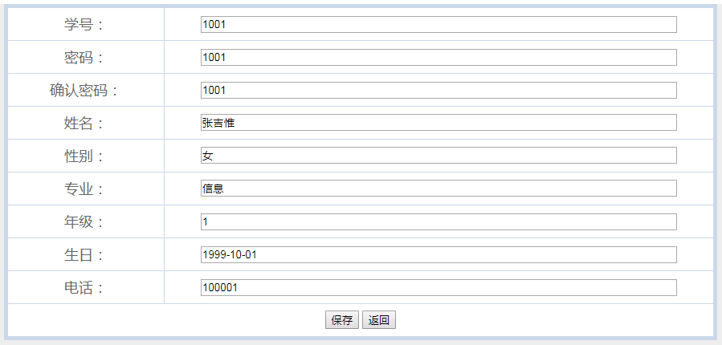

//更新学生信息

**protected** **void** updstu(HttpServletRequest request, HttpServletResponse response) **throws** ServletException, IOException {

String sno = request.getParameter("sno");

String co = request.getParameter("co");

String cco = request.getParameter("cco");

String sna = request.getParameter("sna");

String sg = request.getParameter("sg");

String sd = request.getParameter("sd");

String sgr = request.getParameter("sgr");

String sb = request.getParameter("sb");

String sp = request.getParameter("sp");

StudentBean SB = **new** StudentBean();

**if**(co.equals(cco)) {

SB.upd(sno,sna,sg,sd,sgr,sb,sp,co);

//System.out.println("已更新！！！");

}

**else** {

response.getWriter().print("<script>alert('对不起，你两次输入的密码不一致！')</script>");

}

String admin = request.getParameter("admin");

System.***out***.println("admin "+admin+"!");

**if**(admin.equals("1")) {

response.sendRedirect("studentInformation.jsp");

}

**else**{

response.sendRedirect("myInformation.jsp");

}

}

#### (3)信息删除

//删除学生信息

**protected** **void** delstu(HttpServletRequest request, HttpServletResponse response) **throws** ServletException, IOException {

String nid = request.getParameter("nid");

StudentBean sb = **new** StudentBean();

sb.del(nid);

response.sendRedirect("studentInformation.jsp");

}

### 2.5.2学生成绩查看

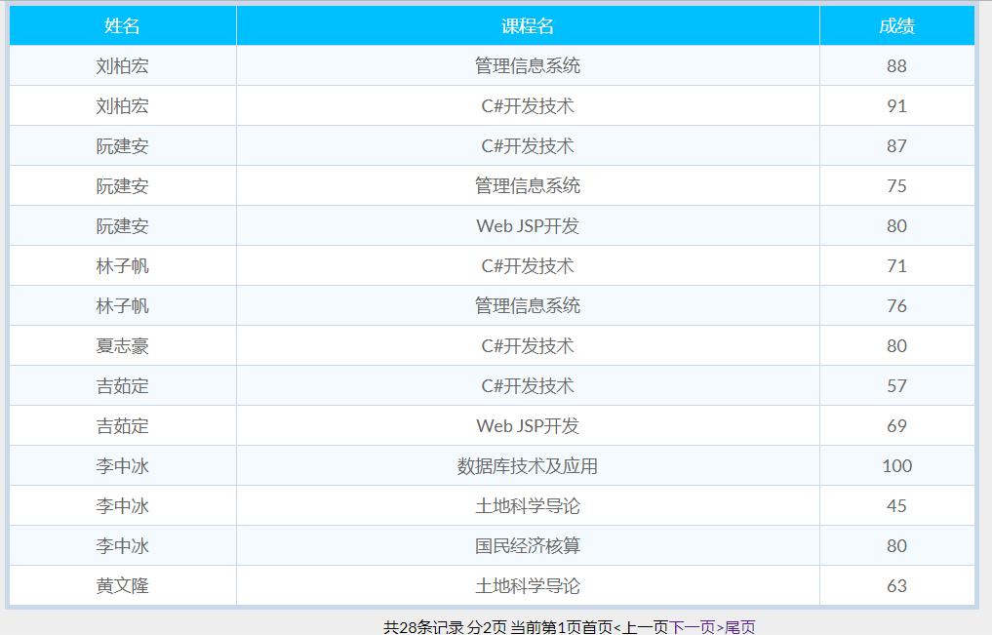

<%

//数据库连接实例

String driverName = "com.mysql.jdbc.Driver";

Class.forName(driverName).newInstance();

String url="jdbc:mysql://localhost:3306/courseselectsystem?user=root&password=caiyishuai";

url += "&useUnicode=true&characterEncoding=utf8";

Connection conn = DriverManager.getConnection(url);

Statement stat = conn.createStatement();

String sql = "select Sname,Cname,Score from v_grade ";

ResultSet rs = stat.executeQuery(sql);

%>

### 2.5.3课程信息管理

#### (1)信息查看

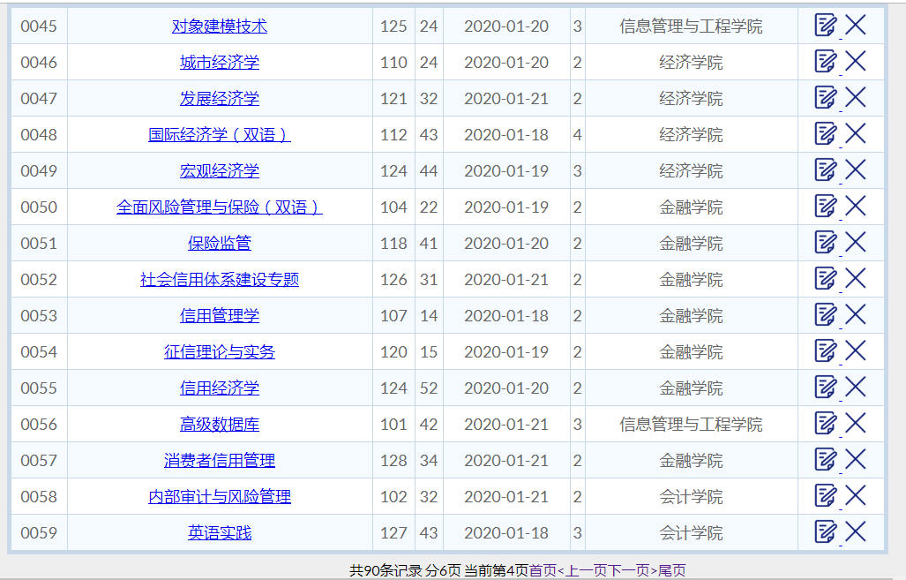

<%

String user =(String)session.getAttribute("username");

session.setAttribute("usernum", user);

List coursetlist = **new** ArrayList();

Course course;

Context initContext = **new** InitialContext();

Context envContext = (Context)initContext.lookup("java:/comp/env");

DataSource ds = (DataSource)envContext.lookup("jdbc/system");

Connection conn = ds.getConnection();

**int** rowCount=0;

**if**(conn != **null**){

Statement stmt = conn.createStatement();

ResultSet rs = stmt.executeQuery("select * from course");

rs.last();

rowCount=rs.getRow();

rs.first();

course = **new** Course(rs.getString(1),rs.getString(2),rs.getString(3),rs.getString(4),rs.getString(5),rs.getString(6),rs.getString(7));

coursetlist.add(course);

**while**(rs.next()){

//System.out.println("rs"+rs);

course = **new** Course(rs.getString(1),rs.getString(2),rs.getString(3),rs.getString(4),rs.getString(5),rs.getString(6),rs.getString(7));

coursetlist.add(course);

}

rs.last();

rowCount=rs.getRow();

rs.close();

stmt.close();

conn.close();

}

**int** who=0;

**if**(user.equals("蔡军帅")){

who=1;

}**else** **if**(user.length()==3){

who=2;

}

%>

#### (2)信息修改

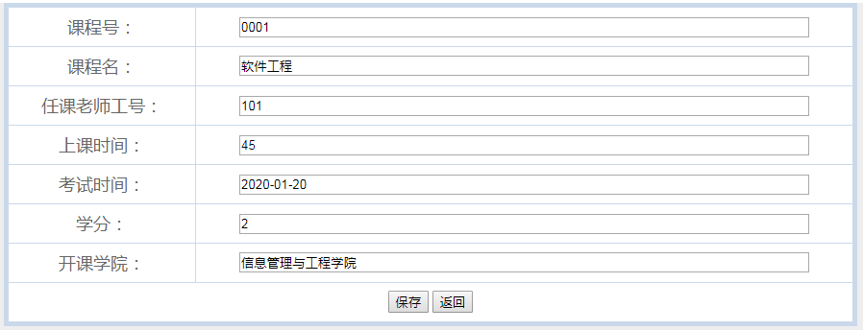

//修改课程

**protected** **void** modcou(HttpServletRequest request, HttpServletResponse response) **throws** ServletException, IOException {

String nid = request.getParameter("nid");

System.***out***.println("nid " +nid);

CourseBean sb = **new** CourseBean();

Course cou = sb.getCourseByCno(nid);

request.setAttribute("one_course", cou);

RequestDispatcher rd;

rd = request.getRequestDispatcher("modCourse.jsp");

rd.forward(request, response);

}

//更新课程

**protected** **void** updcou(HttpServletRequest request, HttpServletResponse response) **throws** ServletException, IOException {

String Cno = request.getParameter("Cno");

String Cname = request.getParameter("Cname");

String Tno = request.getParameter("Tno");

String Time = request.getParameter("Time");

String TestTime = request.getParameter("TestTime");

String Credit = request.getParameter("Credit");

String College = request.getParameter("College");

CourseBean cb = **new** CourseBean();

cb.upd(Cno,Cname,Tno,Time,TestTime,Credit,College);

response.sendRedirect("CourseAdmin.jsp");

}

/**

* **@see** HttpServlet#doGet(HttpServletRequest request, HttpServletResponse response)

*/

**protected** **void** doGet(HttpServletRequest request, HttpServletResponse response) **throws** ServletException, IOException {

// **TODO** Auto-generated method stub

String act = request.getParameter("action");

**if**(act.equals("add")) {

addcou(request, response);

}**else** **if**(act.equals("mod")) {

modcou(request, response);

}**else** **if**(act.equals("del")) {

delcou(request, response);

}**else** **if**(act.equals("upd")) {

updcou(request, response);

}**else** **if**(act.equals("save")) {

inscou(request, response);

}

}

#### (3)信息增加

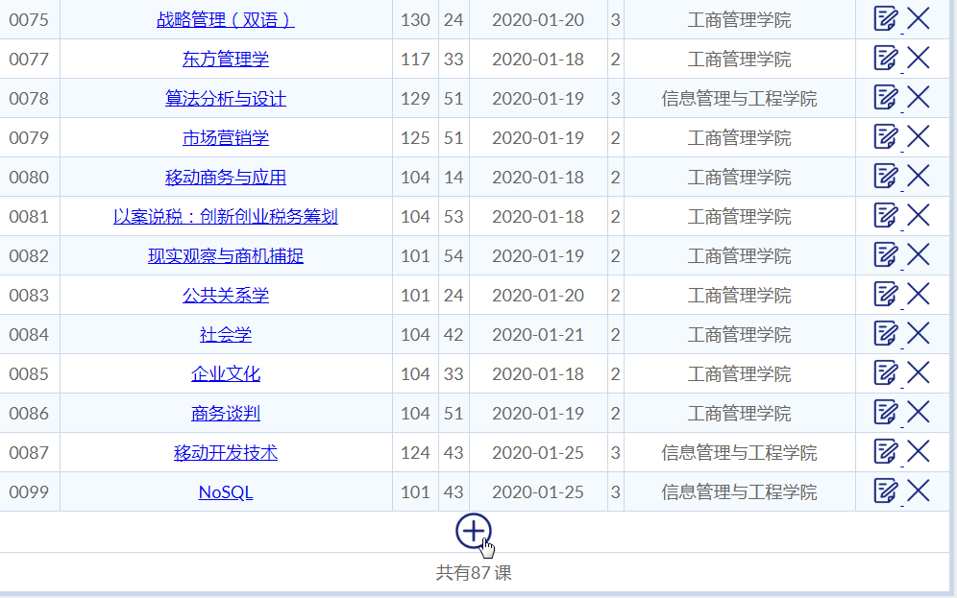

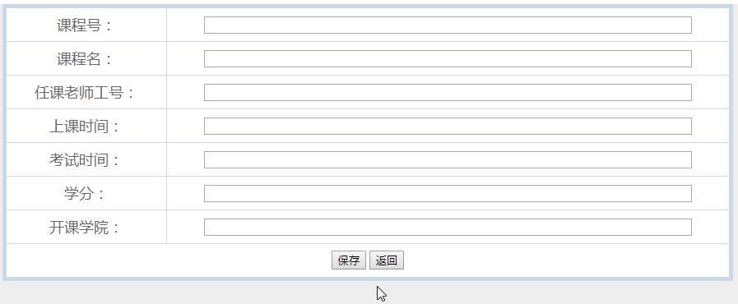

//增加课程

**protected** **void** addcou(HttpServletRequest request, HttpServletResponse response) **throws** ServletException, IOException {

RequestDispatcher rd;

rd = request.getRequestDispatcher("addCourse.jsp");

rd.forward(request, response);

}

//插入课程

**protected** **void** inscou(HttpServletRequest request, HttpServletResponse response) **throws** ServletException, IOException {

String Cno = request.getParameter("Cno");

String Cname = request.getParameter("Cname");

String Tno = request.getParameter("Tno");

String Time = request.getParameter("Time");

String TestTime = request.getParameter("TestTime");

String Credit = request.getParameter("Credit");

String College = request.getParameter("College");

CourseBean cb = **new** CourseBean();

cb.add(Cno,Cname,Tno,Time,TestTime,Credit,College);

response.sendRedirect("CourseAdmin.jsp");

}

#### (4)信息删除

//删除课程

**protected** **void** delcou(HttpServletRequest request, HttpServletResponse response) **throws** ServletException, IOException {

String nid = request.getParameter("nid");

CourseBean cb = **new** CourseBean();

cb.del(nid);

response.sendRedirect("CourseAdmin.jsp");

}

### 2.5.4学生选课情况

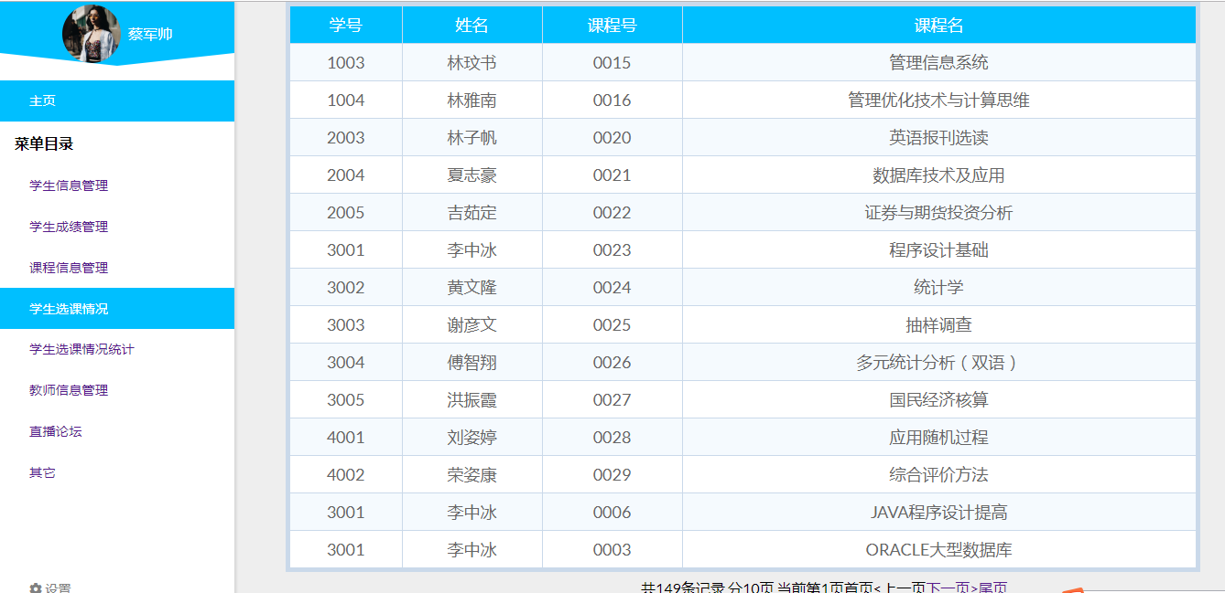

<%

//数据库连接实例

String driverName = "com.mysql.jdbc.Driver";

Class.forName(driverName).newInstance();

String url="jdbc:mysql://localhost:3306/courseselectsystem?user=root&password=caiyishuai";

url += "&useUnicode=true&characterEncoding=utf8";

Connection conn = DriverManager.getConnection(url);

Statement stat = conn.createStatement();

String sql = "select * from v_selected_admin ";

ResultSet rs = stat.executeQuery(sql);

%>

### 2.5.5学生选课情况统计

#### (1)按学院统计

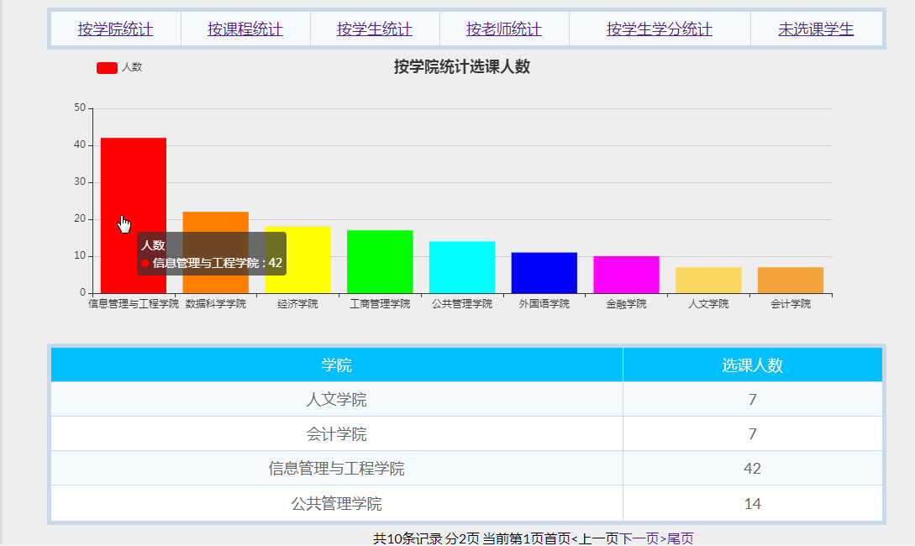

<%

String user =(String)session.getAttribute("username");

session.setAttribute("username", user);

//数据库连接实例

String driverName = "com.mysql.jdbc.Driver";

Class.forName(driverName).newInstance();

//Class c = new Class(driverName);

String url="jdbc:mysql://localhost:3306/courseselectsystem?user=root&password=caiyishuai";

url += "&useUnicode=true&characterEncoding=utf8";

//建立数据库连接

Connection conn = DriverManager.getConnection(url);

//out.println(conn);//能输出就连接成功了

//建立语句执行环境

Statement stat = conn.createStatement();

//执行sql语句

String sql = "select * from v_count_college";

System.out.println("sql "+sql);

//弄个对象来接它，结果集

ResultSet rs = stat.executeQuery(sql);

%>

<script type=*"text/javascript"*>

**var** myChart = echarts.init(document.getElementById('main'));

//3.初始化，默认显示标题，图例和xy空坐标轴

myChart.setOption({

title : {

text : '按学院统计选课人数',

x:'center',

y:'top'

},

tooltip : {},

legend : {

data : [ '人数' ],

left:'10%',

},

xAxis : {

data : []

},

yAxis : {},

series : [ {

name : '人数',

type : 'bar',

data : []

} ]

});

//4.设置加载动画(非必须)

myChart.showLoading(); //数据加载完之前先显示一段简单的loading动画

//5.定义数据存放数组(动态变)

**var** names = []; //建立一个类别数组（实际用来盛放X轴坐标值）

**var** nums = []; //建立一个销量数组（实际用来盛放Y坐标值）

//6.ajax发起数据请求

$.ajax({

type : "post",

async : **true**, //异步请求（同步请求将会锁住浏览器，其他操作须等请求完成才可执行）

url : "TestServlet", //请求发送到TestServlet

data : {},

dataType : "json", //返回数据形式为json

//7.请求成功后接收数据name+num两组数据

success : **function**(result) {

//result为服务器返回的json对象

**if** (result) {

//8.取出数据存入数组

**for** (**var** i = 0; i < result.length; i++) {

names.push(result[i].name); //迭代取出类别数据并填入类别数组

}

**for** (**var** i = 0; i < result.length; i++) {

nums.push(result[i].num); //迭代取出数量并填入销量数组

}

myChart.hideLoading(); //隐藏加载动画

//9.覆盖操作-根据数据加载数据图表

myChart.setOption({

xAxis : {

data : names,

axisLabel:{

interval:0,//横轴信息全部显示

}

},

series : [ {

// 根据名字对应到相应的数据

name : '人数',

data : nums,

itemStyle: {

normal: {

color: **function**(params) {

// build a color map as your need.

**var** colorList = [

'#FF0000','#FF7D00','#FFFF00','#00FF00','#00FFFF',

'#0000FF','#FF00FF','#FAD860','#F3A43B','#60C0DD',

'#D7504B','#C6E579','#F4E001','#F0805A','#26C0C0'

];

**return** colorList[params.dataIndex];

},

}

},

} ]

});

}

},

error : **function**(errorMsg) {

//请求失败时执行该函数

alert("图表请求数据失败!");

myChart.hideLoading();

}

})

</script>

**protected** **void** doPost(HttpServletRequest request, HttpServletResponse response)

**throws** ServletException, IOException {

String sql = "select * from v_count_college order by number desc";

//System.out.println(sql);

List<Product> list = **new** ArrayList<Product>();

DBBean db = **new** DBBean();

db.getConnection();

ResultSet rs = db.executeQuery(sql);

**try** {

**while**(rs.next())

{

list.add(**new** Product(rs.getString(1), rs.getInt(2)));

System.***out***.println(rs.getString(1));

}

}**catch**(Exception e) {

e.printStackTrace();

}

System.***out***.println("这里是doPost");

//定义一个list集合

Gson gson2 = **new** Gson();

String json = gson2.toJson(list);

System.***out***.println(json);

// 将json字符串数据返回给前端

response.setContentType("text/html; charset=utf-8");

response.getWriter().write(json);

}

#### (2)按课程统计

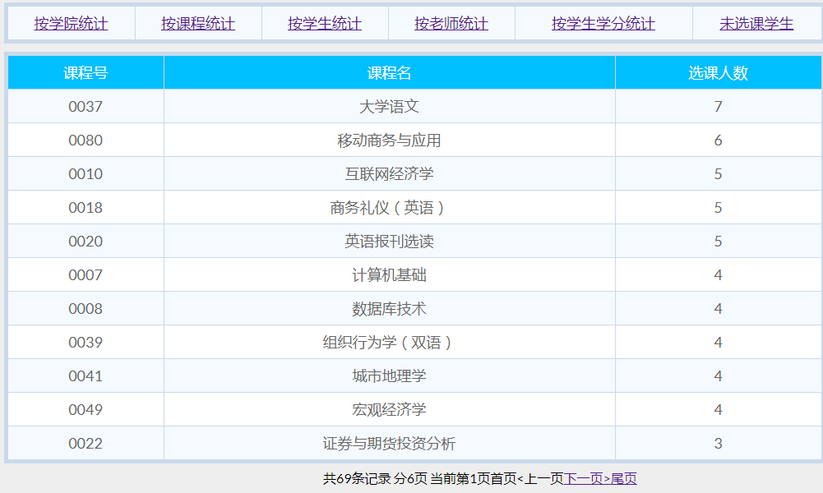

<%

String user =(String)session.getAttribute("username");

session.setAttribute("username", user);

//数据库连接实例

String driverName = "com.mysql.jdbc.Driver";

Class.forName(driverName).newInstance();

String url="jdbc:mysql://localhost:3306/courseselectsystem?user=root&password=caiyishuai";

url += "&useUnicode=true&characterEncoding=utf8";

Connection conn = DriverManager.getConnection(url);

Statement stat = conn.createStatement();

String sql = "select v_selected_stu_tea_cou.Cno,v_selected_stu_tea_cou.Cname,COUNT(*) ";

sql+="from v_selected_stu_tea_cou,course ";

sql+="where v_selected_stu_tea_cou.Cno = course.Cno ";

sql+="group by Cno ";

sql+="order by COUNT(*) desc ";

System.out.println("sql "+sql);

ResultSet rs = stat.executeQuery(sql);

%>

#### (3)按学生统计

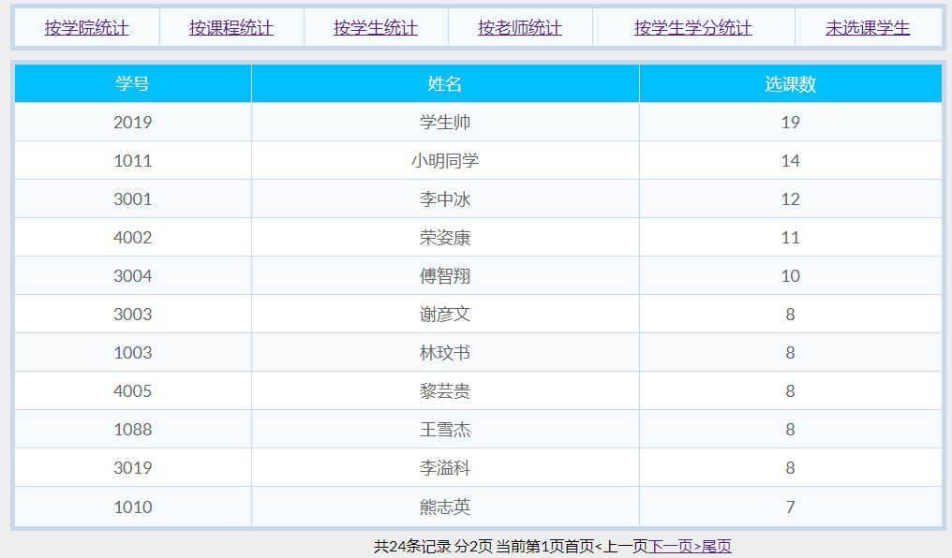

<%

String user =(String)session.getAttribute("username");

session.setAttribute("username", user);

//数据库连接实例

String driverName = "com.mysql.jdbc.Driver";

Class.forName(driverName).newInstance();

//Class c = new Class(driverName);

String url="jdbc:mysql://localhost:3306/courseselectsystem?user=root&password=caiyishuai";

url += "&useUnicode=true&characterEncoding=utf8";

//建立数据库连接

Connection conn = DriverManager.getConnection(url);

//out.println(conn);//能输出就连接成功了

//建立语句执行环境

Statement stat = conn.createStatement();

//执行sql语句

String sql = "select Sno,Sname,count(*) ";

sql+="from v_selected_stu_tea_cou ";

sql+="group by Sno ";

sql+="order by count(*) desc";

System.out.println("sql "+sql);

//弄个对象来接它，结果集

ResultSet rs = stat.executeQuery(sql);

//rs.last();//先到最后一行

//out.println("共有"+rs.getRow()+"人");//看看行号输出

%>

#### (4)按老师统计

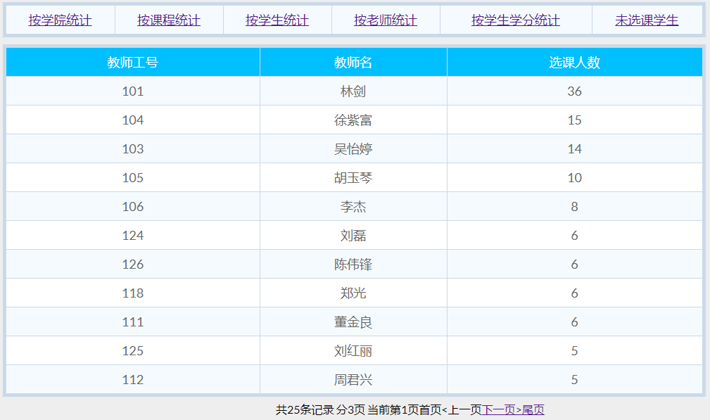

<%

String user =(String)session.getAttribute("username");

session.setAttribute("username", user);

String driverName = "com.mysql.jdbc.Driver";

Class.forName(driverName).newInstance();

String url="jdbc:mysql://localhost:3306/courseselectsystem?user=root&password=caiyishuai";

url += "&useUnicode=true&characterEncoding=utf8";

Connection conn = DriverManager.getConnection(url);

Statement stat = conn.createStatement();

String sql = "select Tno,Tname,count(*) ";

sql+="from v_selected_stu_tea_cou ";

sql+="group by Tno ";

sql+="order by count(*) desc";

System.out.println("sql "+sql);

ResultSet rs = stat.executeQuery(sql);

%>

#### (5)按学生学分统计

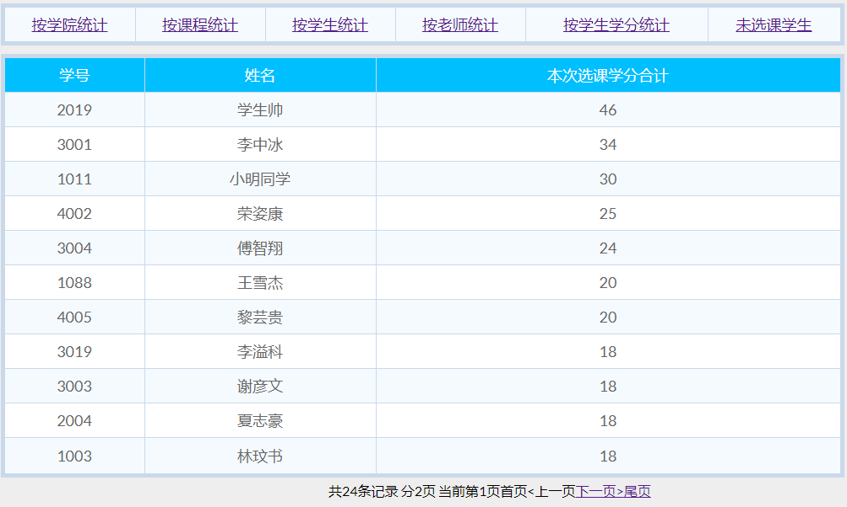

<%

String user =(String)session.getAttribute("username");

session.setAttribute("username", user);

//数据库连接实例

String driverName = "com.mysql.jdbc.Driver";

Class.forName(driverName).newInstance();

//Class c = new Class(driverName);

String url="jdbc:mysql://localhost:3306/courseselectsystem?user=root&password=caiyishuai";

url += "&useUnicode=true&characterEncoding=utf8";

//建立数据库连接

Connection conn = DriverManager.getConnection(url);

//out.println(conn);//能输出就连接成功了

//建立语句执行环境

Statement stat = conn.createStatement();

//执行sql语句

String sql = "select Sno,Sname,SUM(course.Credit)";

sql+="from v_selected_stu_tea_cou,course ";

sql+="where v_selected_stu_tea_cou.Cno = course.Cno ";

sql+="group by Sno ";

sql+="order by SUM(course.Credit) desc ";

System.out.println("sql "+sql);

//弄个对象来接它，结果集

ResultSet rs = stat.executeQuery(sql);

%>

#### (6)未选课学生

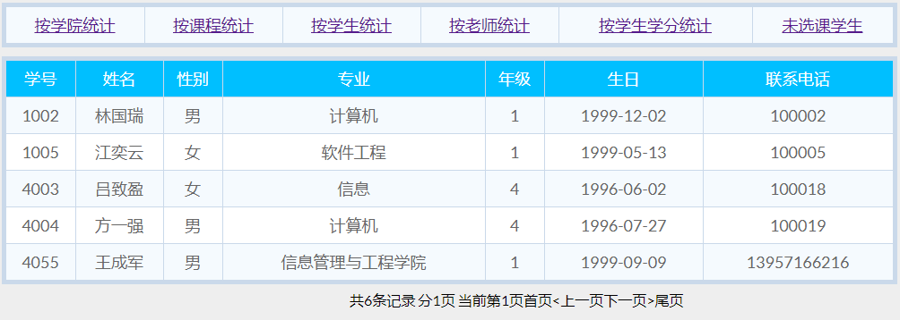

<%

String user =(String)session.getAttribute("username");

session.setAttribute("username", user);

String driverName = "com.mysql.jdbc.Driver";

Class.forName(driverName).newInstance();

String url="jdbc:mysql://localhost:3306/courseselectsystem?user=root&password=caiyishuai";

url += "&useUnicode=true&characterEncoding=utf8";

//建立数据库连接

Connection conn = DriverManager.getConnection(url);

Statement stat = conn.createStatement();

//执行sql语句

String sql = "select * ";

sql+="from student ";

sql+="where Sno not in ";

sql+="(select Sno from v_selected_stu_tea_cou)";

System.out.println("sql "+sql);

ResultSet rs = stat.executeQuery(sql);

%>

### 2.5.6 教师信息查看

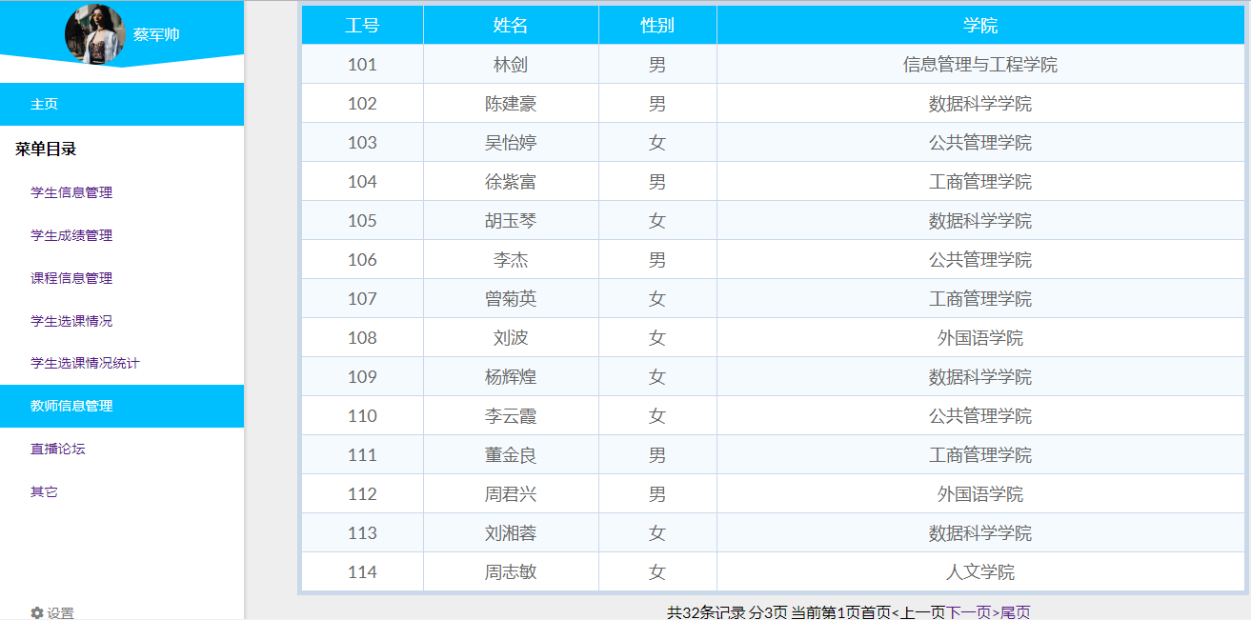

<%

String driverName = "com.mysql.jdbc.Driver";

Class.forName(driverName).newInstance();

String url="jdbc:mysql://localhost:3306/courseselectsystem?user=root&password=caiyishuai";

url += "&useUnicode=true&characterEncoding=utf8";

Connection conn = DriverManager.getConnection(url);

Statement stat = conn.createStatement();

String sql = "select * from teacher ";

ResultSet rs = stat.executeQuery(sql);

%>

# 三、软件所涉及到的数据表：

#### (1)用户登录表(user)



#### (2)学生信息表(student)

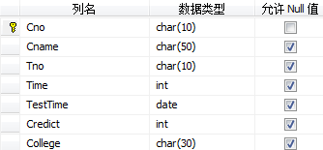

#### (3)课程信息表(course)

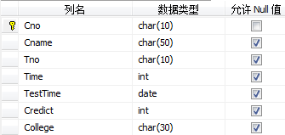

#### (4)成绩信息表(cscore)

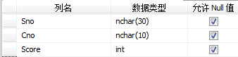

#### (5)学生选课表(selection)



# 四、Sql server中的代码（事务，视图，触发器，存储过程）

## 4.1触发器

**触发器:**使Student表学号位数保持4位且必须以“1”或“2”或“3”或“4”开头，否则撤销相应操作；

CREATE TRIGGER tri_insert_sno

ON student

FOR INSERT

AS

DECLARE @sno VARCHAR(8)

SELECT @sno = Sno FROM inserted

IF(LEN(@sno)=4)

BEGIN

IF(@sno LIKE '1%' or @sno LIKE '2%'or @sno LIKE '2%'or @sno LIKE '2%')

PRINT '增加成功'

END

ELSE

BEGIN

RAISERROR('学号不对',16,1)

ROLLBACK TRANSACTION

END

GO

**触发器:**使Teacher表学号位数保持3位且必须以“1”开头，否则撤销相应操作；

CREATE TRIGGER tri_insert_tno

ON teacher

FOR INSERT

AS

DECLARE @tno VARCHAR(8)

SELECT @tno = Tno FROM inserted

IF(LEN(@tno)=3)

BEGIN

IF(@tno LIKE '1%')

PRINT '增加成功'

END

ELSE

BEGIN

RAISERROR('工号不对',16,1)

ROLLBACK TRANSACTION

END

GO

**触发器:**若Course表中的课程号发生变化，在SC表中的对应课程号也相应变化

CREATE TRIGGER tri_update_changeCno

ON course

FOR UPDATE

AS

DECLARE @CnoA VARCHAR(8),@CnoB VARCHAR(8)

SELECT @CnoB = Cno FROM deleted

SELECT @CnoA = Cno FROM inserted

IF UPDATE(Cno)

BEGIN

UPDATE cscore SET Cno = @CnoA

WHERE Cno = @CnoB

END

GO

**触发器:**在学生信息表Student上创建触发器，当数据删除学生记录时，判断如果该学生已经有考试成绩，则不允许删除；

CREATE TRIGGER tri_delete_Dgrade

ON student

FOR DELETE

AS

IF EXISTS(SELECT cscore.Sno FROM cscore,deleted WHERE deleted.Sno = cscore.Sno AND Score IS NOT NULL)

BEGIN

PRINT 'NOT ALLOWED TO DELETE'

RAISERROR('THE STUDENT Grade IS NOT NULL',16,1)

ROLLBACK TRANSACTION

END

GO

**触发器:**当删除学生表中的学生记录时，同步删除选课表中该学生的选课信息；

CREATE TRIGGER tri_delete_DSinfo

ON student

FOR DELETE

AS

IF EXISTS(SELECT cscore.Sno FROM deleted,Score WHERE cscore.Sno = deleted.Sno)

DELETE FROM cscore WHERE Sno IN(SELECT Sno FROM deleted)

GO

在mysql里

create trigger del_stu

after delete on student

for each row

delete from selection where Sno = old.Sno

**触发器:**当增加学生表中的学生记录时，同时增加登录信息表的账号密码

CREATE TRIGGER tri_insert_account

ON student

AFTER INSERT

AS

BEGIN INSERT INTO user(uid,ucode)

SELECT Sno,Sno

FROM INSERTED

END

**触发器:**当增加教师表中的学生记录时，同时增加登录信息表的账号密码

在mysql里

CREATE TRIGGER tri_insert_Taccount

ON teacher

AFTER INSERT

AS

BEGIN INSERT INTO user(uid,ucode)

SELECT Tno,Tno

FROM INSERTED

END

**触发器:**删除一个老师时，则删除所有该老师开的所有课的选课记录

create trigger del_tea

after delete on teacher

for each row

delete from selection where Cno in(

select Cno from course where Tno = old.Tno

)

## 4.2视图

**视图:**创建学生成绩展示视图

CREATE VIEW v_grade AS

select student.Sno,student.Sname,course.Cno,course.Cname,cscore.Score

from student,course,cscore

where cscore.Sno=student.Sno and cscore.Cno=course.Cno;

**视图:**创建学生选课结果展示视图

create view v_selected as

select selection.Sno,student.Sname,selection.Cno,course.Cname

from student,course,selection

where student.Sno=selection.Sno and course.Cno=selection.Cno;

**视图:**创建学号和学院的视图

create view v_selected_college as

select v_selected_admin.Sno,College from v_selected_admin,course where course.Cno=v_selected_admin.Cno;

**视图:**创建按学院统计选课人数的视图

create view v_count_college as

select College,count(*) from v_selected_college group by College;

**视图:**创建选课呈现给学生的视图

create view v_choose_course as

select Cno,Cname,Tname,Time,TestTime,Credit,College

from course,teacher

where teacher.Tno=course.Tno

**视图:**创建含学生老师课程的已选课视图

create view v_selected_stu_tea_cou as

select selection.Sno,Sname,teacher.Tno,Tname,selection.Cno,course.Cname

from selection,course,teacher,student

where selection.Cno = course.Cno

and teacher.Tno = course.Tno

and selection.Sno = student.Sno

# 五、课程设计心得

通过此次课程设计，加深了我们对Java这门语言和数据库操作的了解，熟悉了数据库的工作原理。在整个过程中，我们遇到了许多的问题，包括对一些控件功能的不了解，调试时出现的种种错误，效果与预期不相符，以及对两种语言的结合使用等等。通过查找网络资料以及翻阅教辅书，最终将所遇到的问题逐一解决。